https://explore.skillbuilder.aws/learn/course/134/play/31418/aws-cloud-practitioner-essentials-all-modules

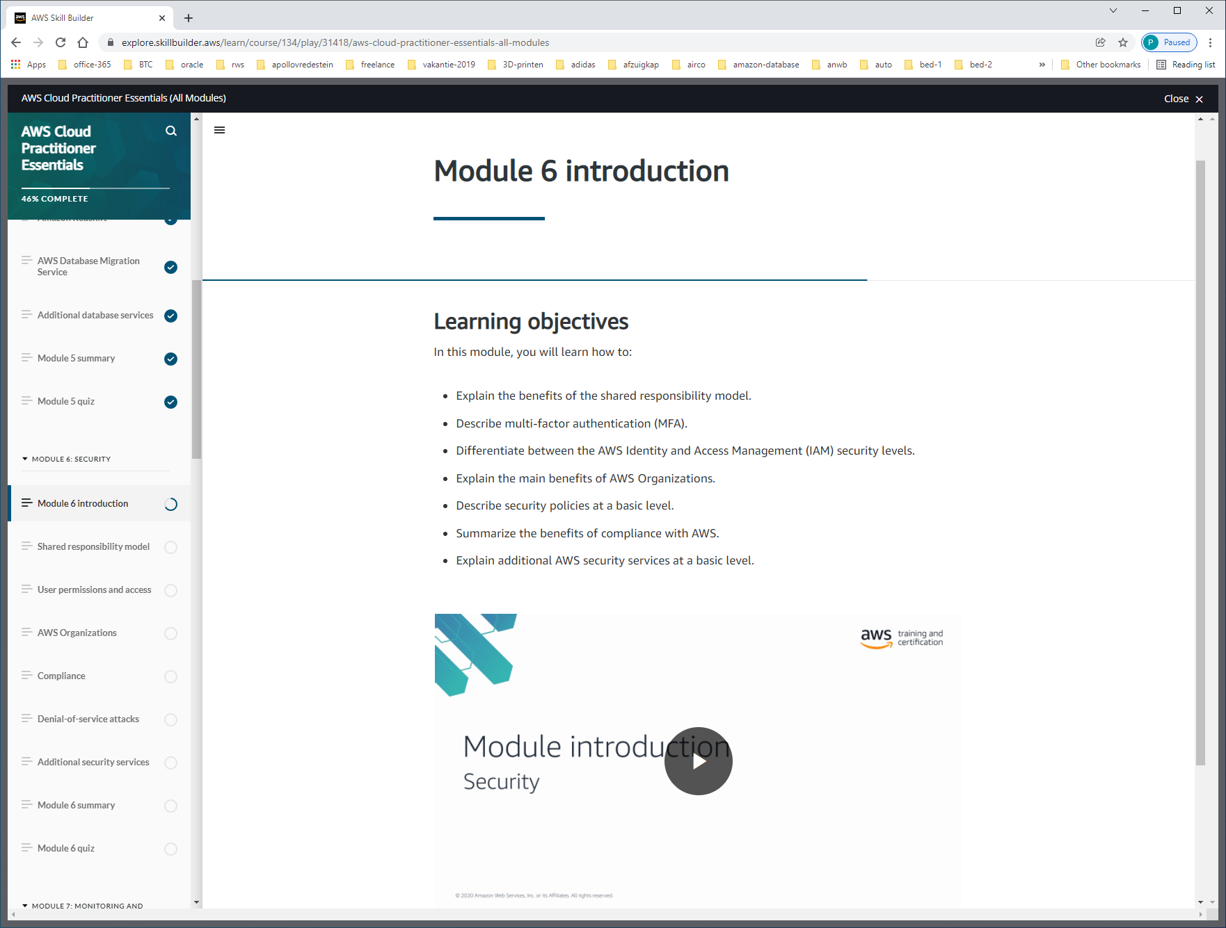

SHARED-RESPONSIBILITY-MODEL

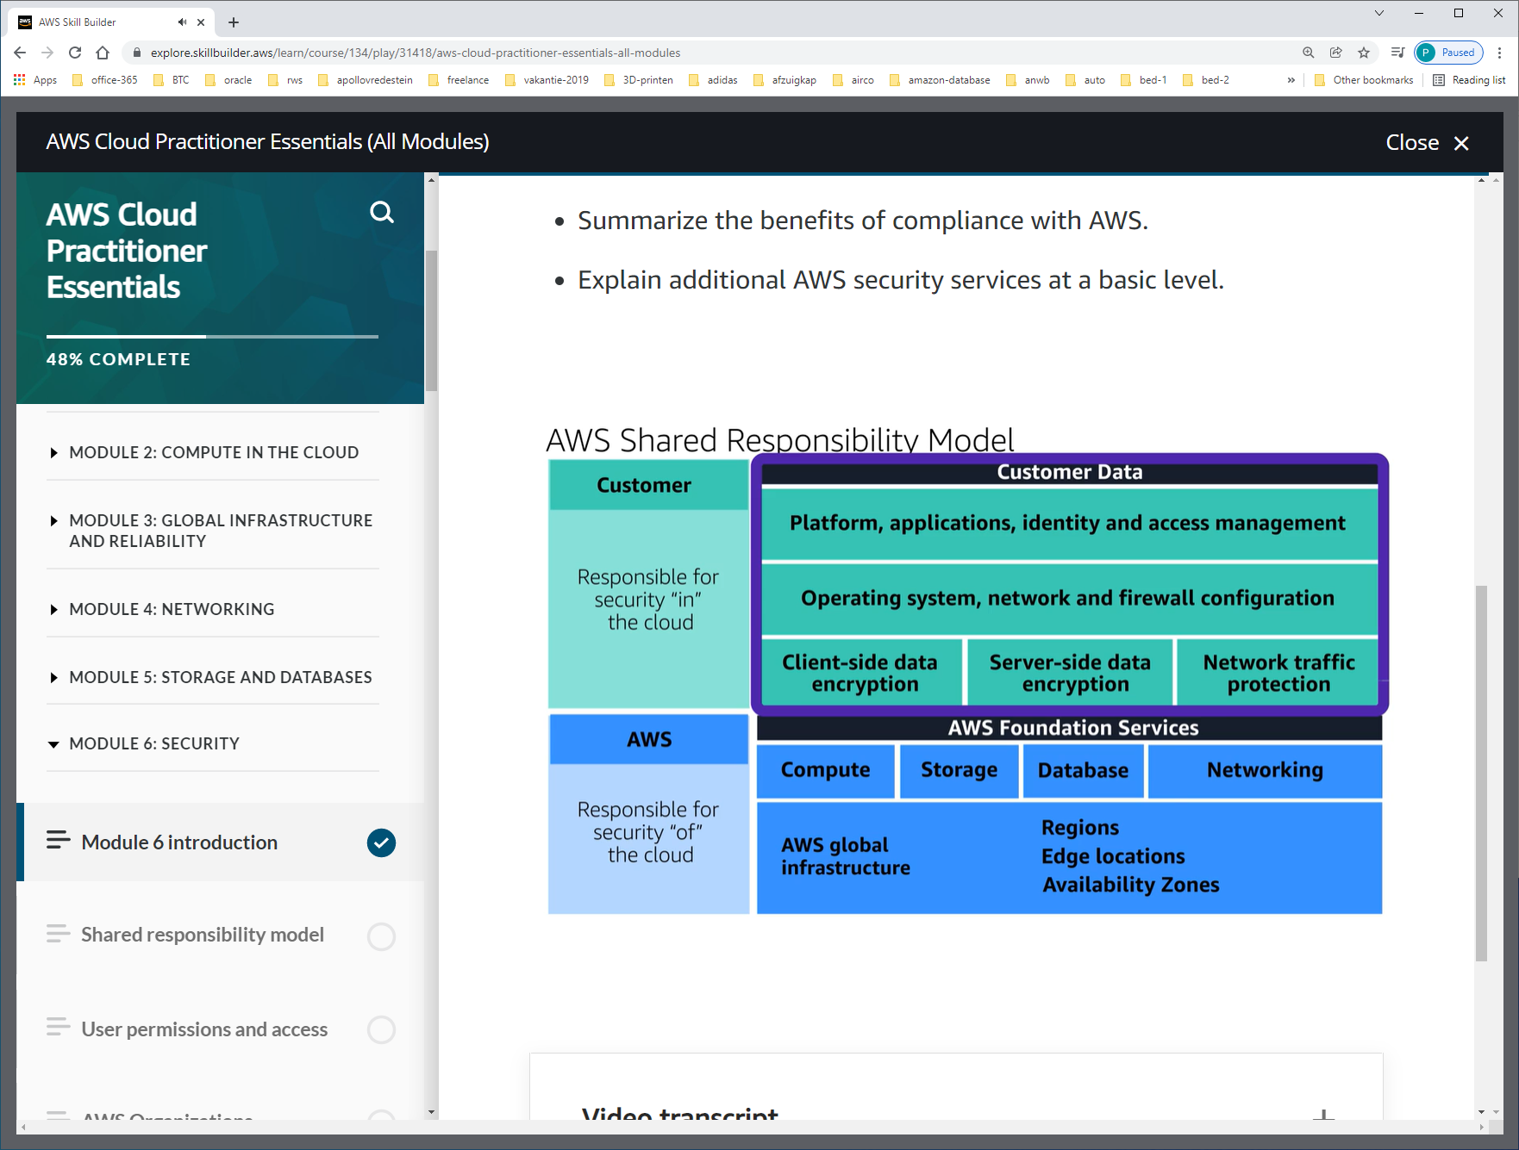

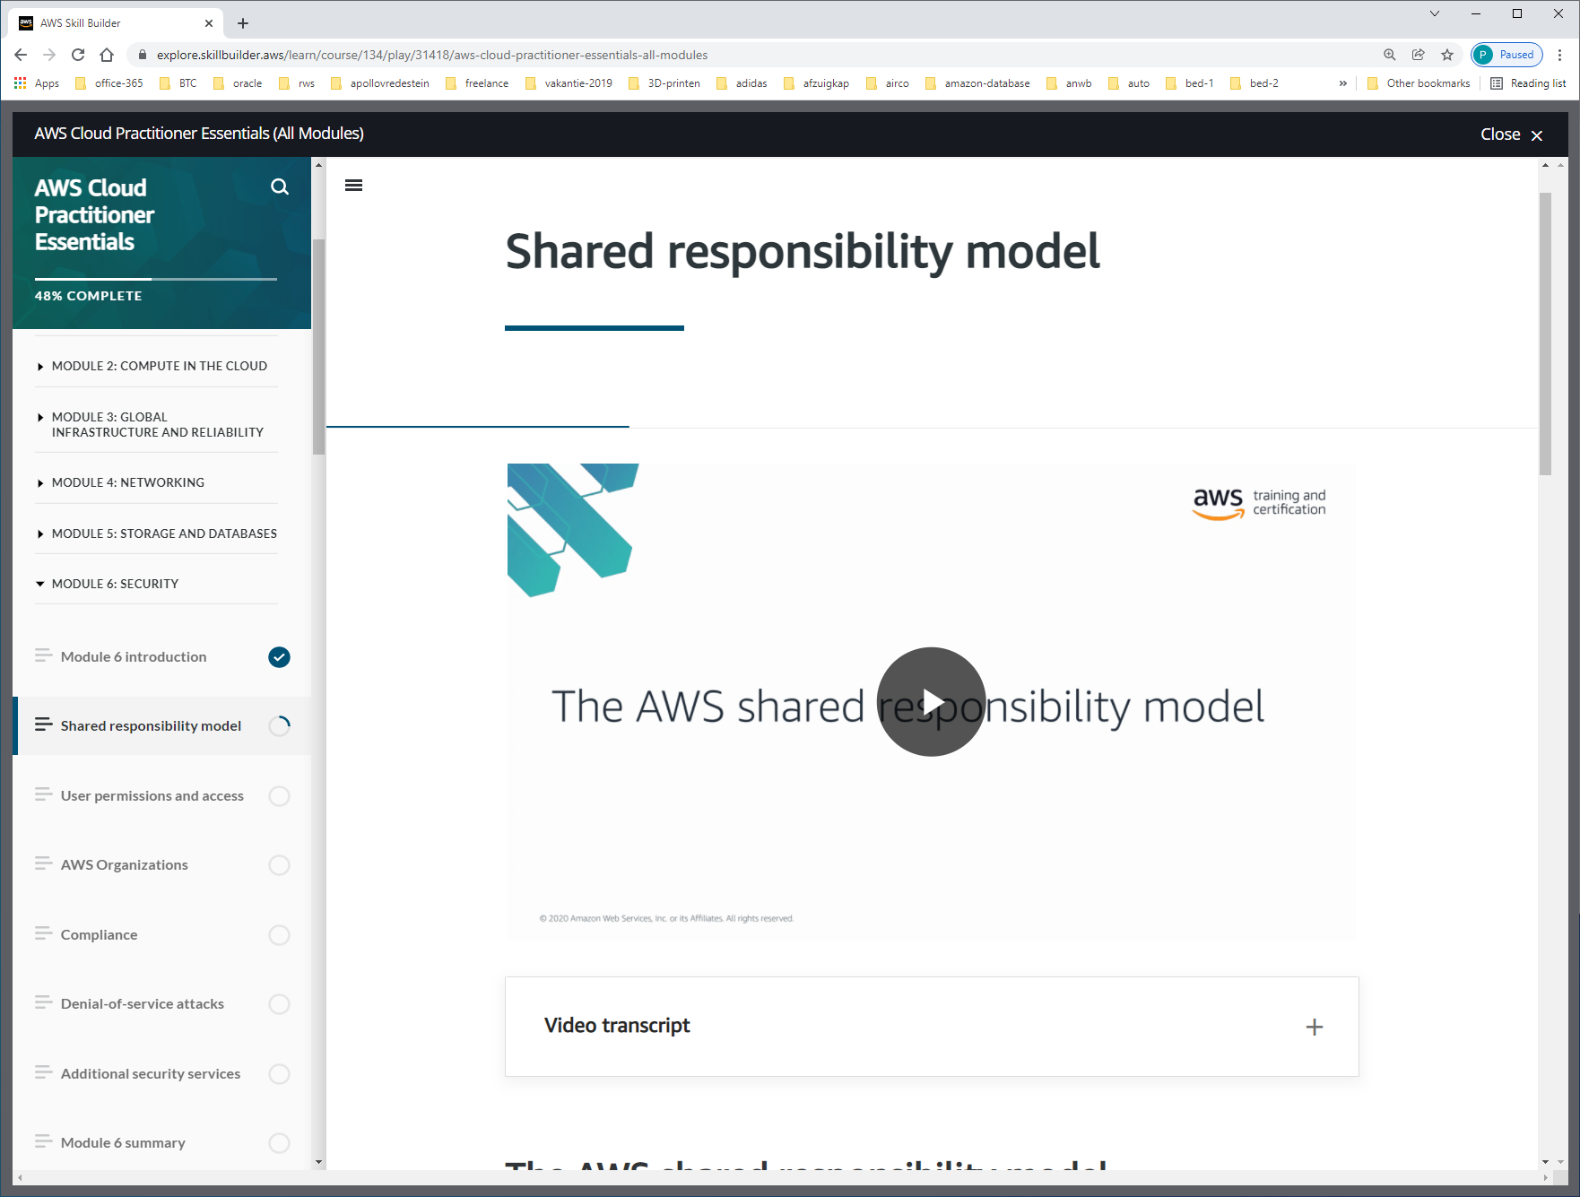

BIJV. VOOR EC2

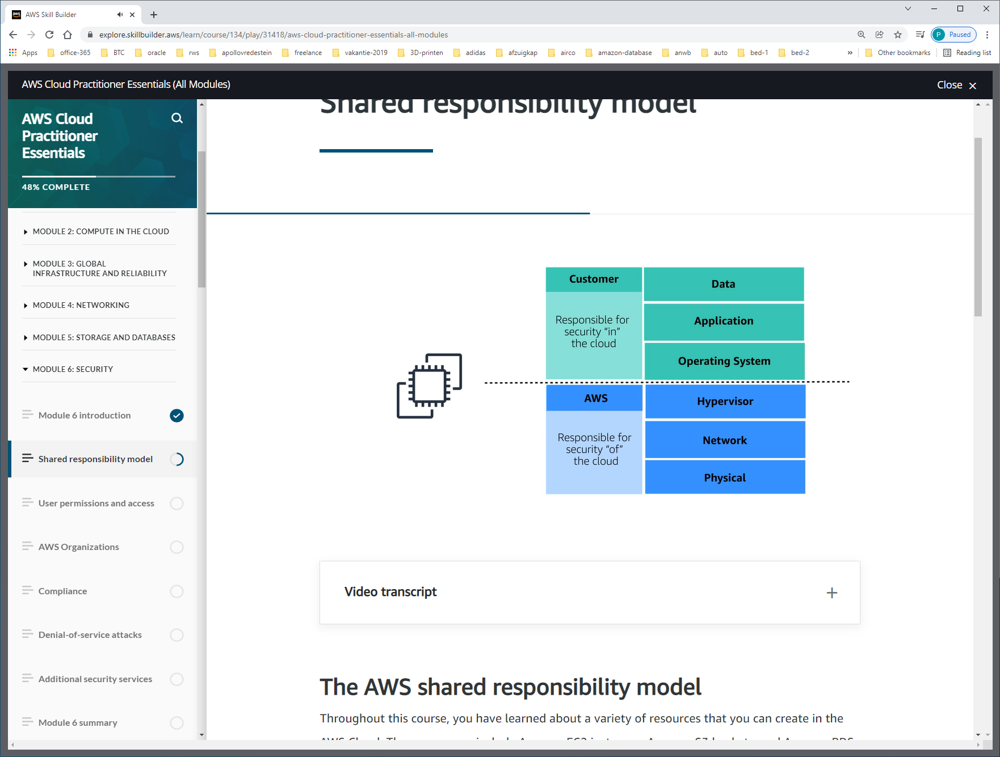

OS is van customer. Je hebt alleen root-user access, not AWS.

Dus moet customer ook zelf voor patches etc. zorgen !!!! Er kan dus ook niemand anders iets installeren wat ervoor zorgt dat service crashed.

**Customers: Security in the cloud**

Customers are responsible for the security of everything that they create and put *in*the AWS Cloud.

When using AWS services, you, the customer, maintain complete control over your content. You are responsible for   
-managing security requirements for your content,   
-including which content you choose to store on AWS,   
-which AWS services you use,   
-and who has access to that content.   
-You also control how access rights are granted, managed, and revoked.

The security steps that you take will depend on factors such as the services that you use, the complexity of your systems, and your company’s specific operational and security needs. Steps include selecting, configuring, and patching the operating systems that will run on Amazon EC2 instances, configuring security groups, and managing user accounts.

**AWS: Security of the cloud**

AWS is responsible for security *of*the cloud.

AWS operates, manages, and controls the components at all layers of infrastructure. This includes areas such as   
-the host operating system,   
-the virtualization layer,   
-and even the physical security of the data centers from which services operate.

AWS is responsible for protecting the global infrastructure that runs all of the services offered in the AWS Cloud. This infrastructure includes AWS Regions, Availability Zones, and edge locations.

AWS manages the security of the cloud, specifically the physical infrastructure that hosts your resources, which include:

* Physical security of data centers
* Hardware and software infrastructure
* Network infrastructure
* Virtualization infrastructure

Although you cannot visit AWS data centers to see this protection firsthand, AWS provides several reports from third-party auditors. These auditors have verified its compliance with a variety of computer security standards and regulations.

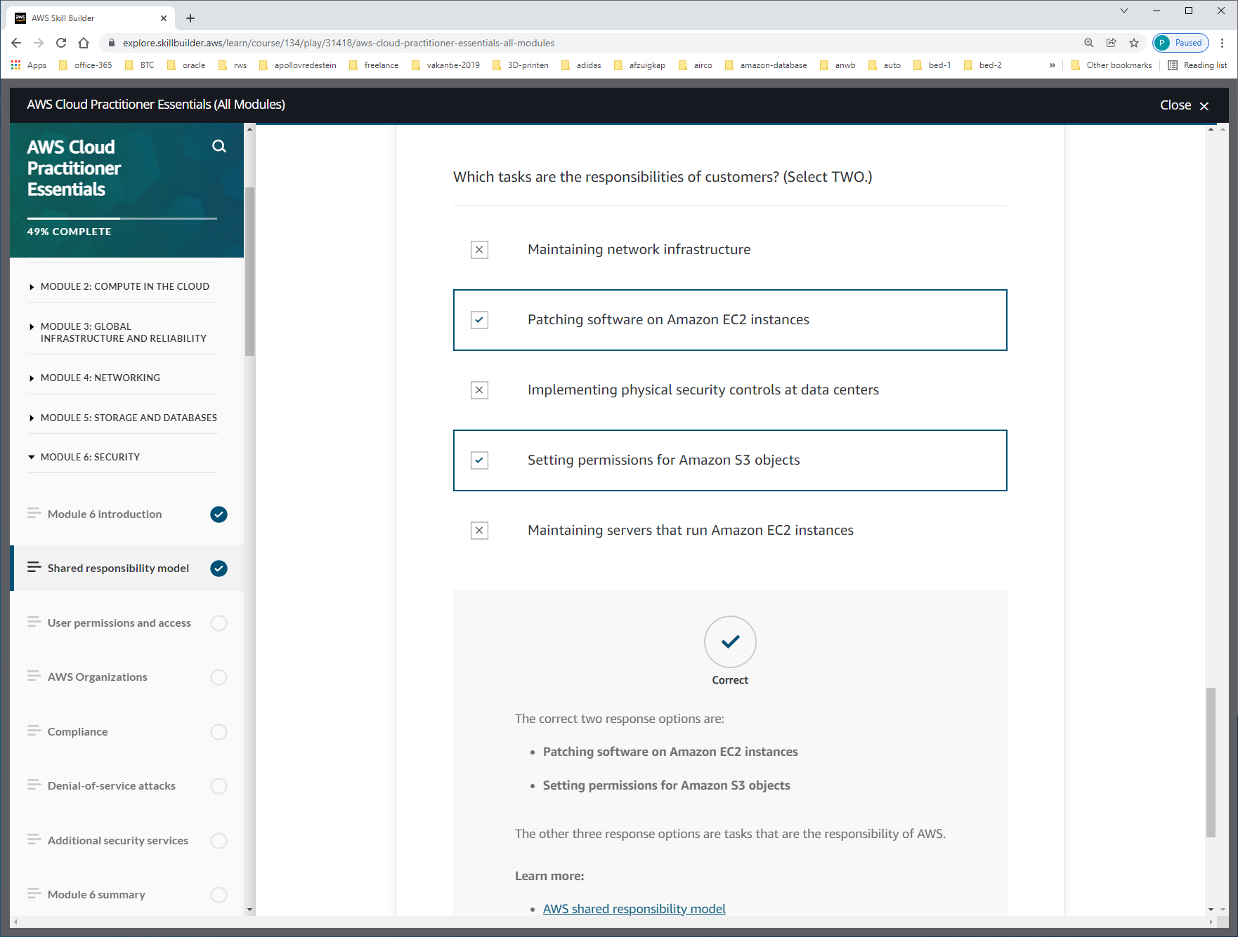

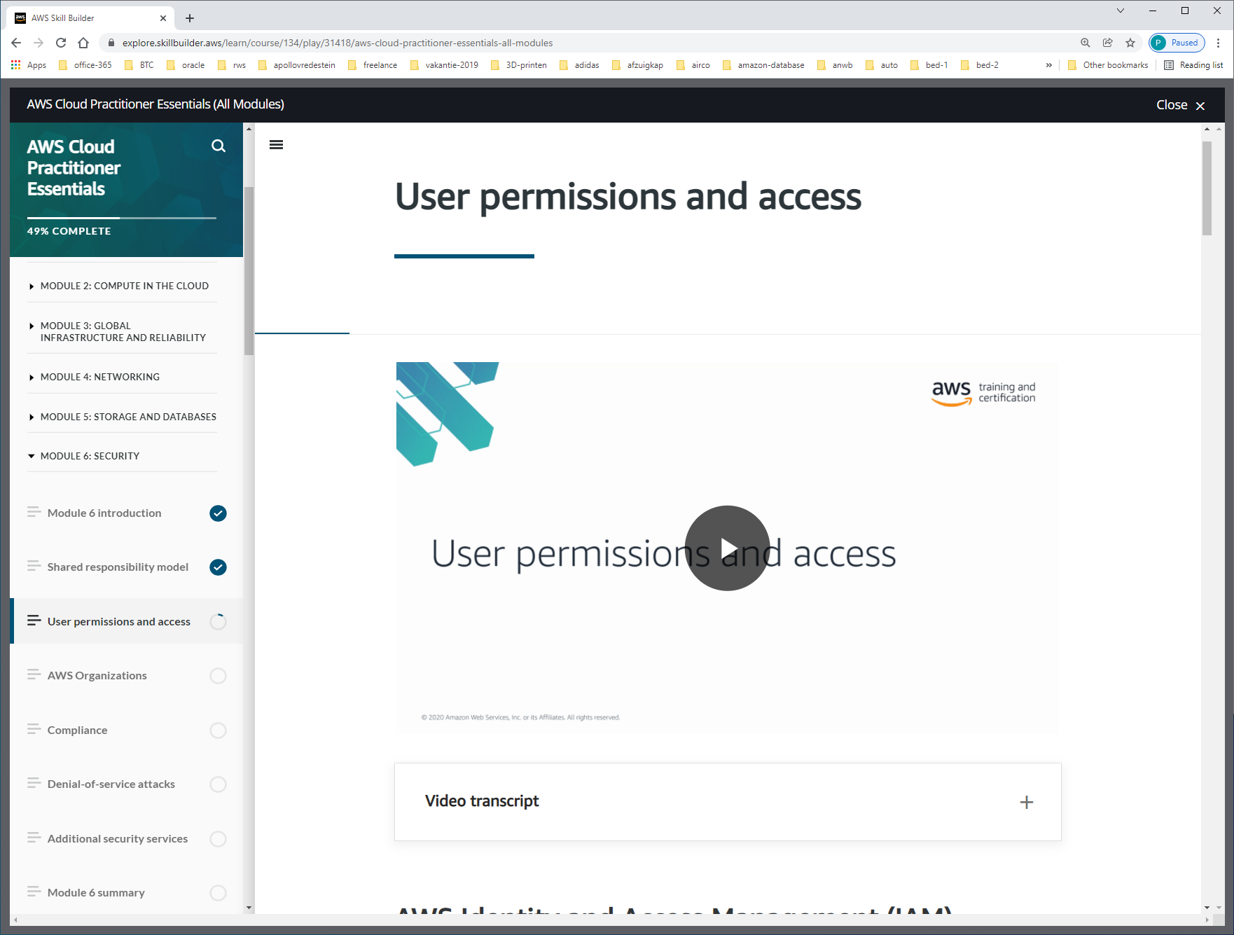

IAM gives you the flexibility to configure access based on your company’s specific operational and security needs. You do this by using a combination of IAM features, which are explored in detail in this lesson:

* IAM users, groups, and roles
* IAM policies
* Multi-factor authentication

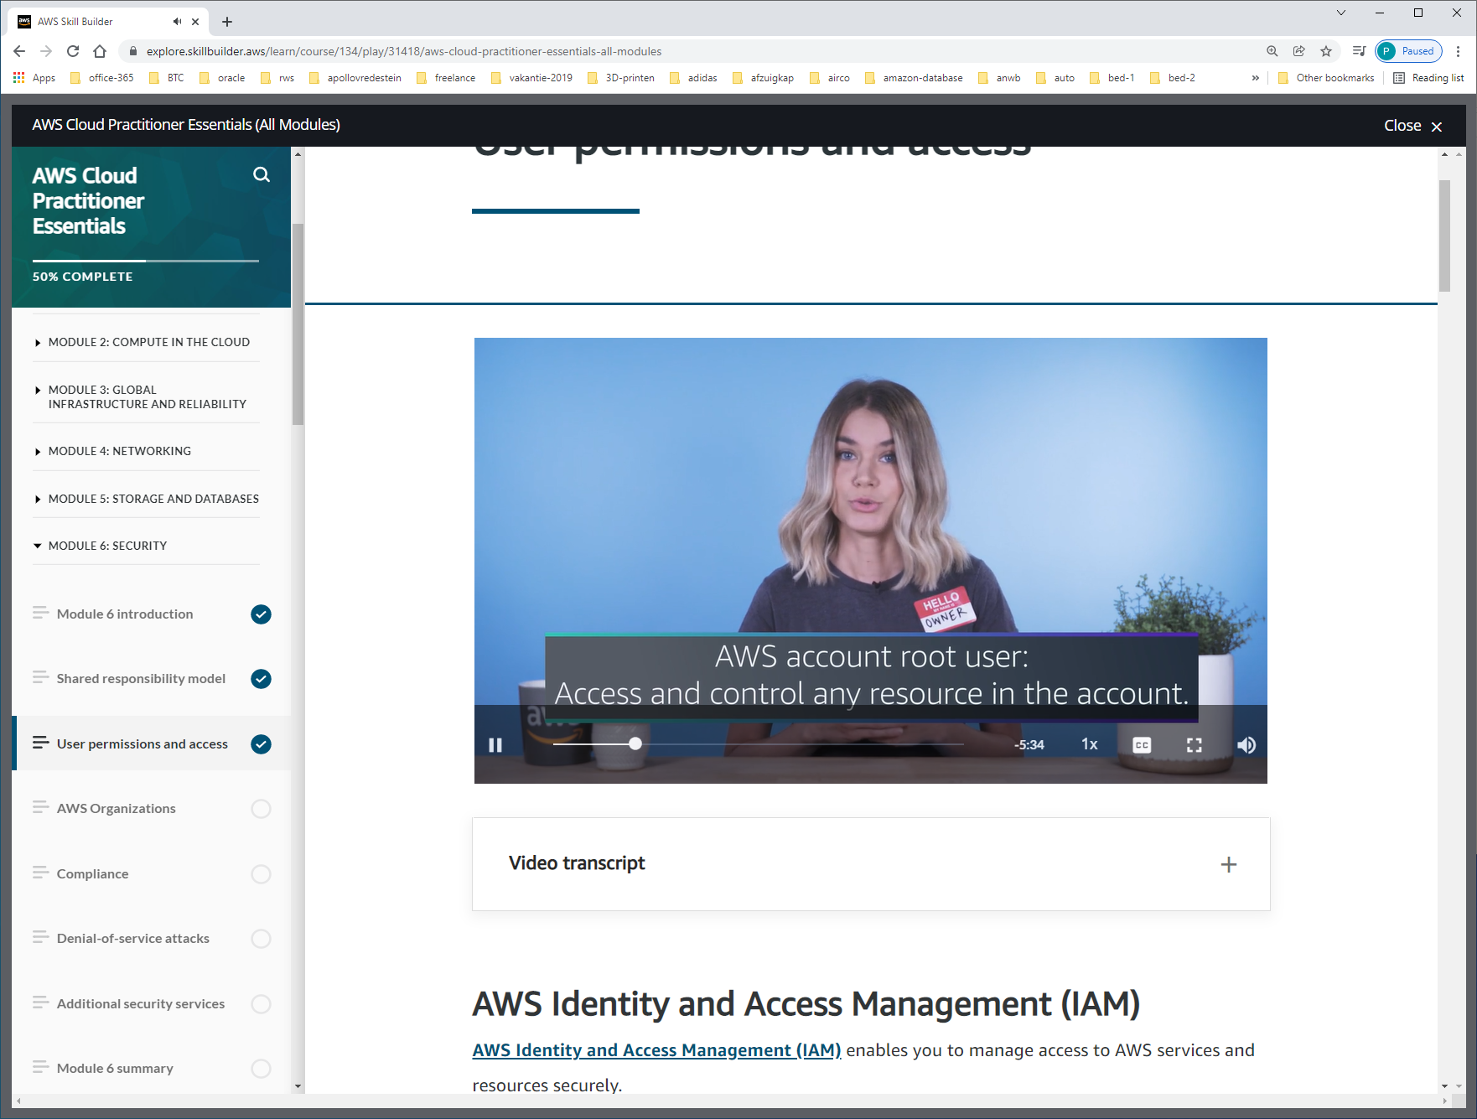

When you first create an AWS account, you begin with an identity known as the [**root user**](https://docs.aws.amazon.com/IAM/latest/UserGuide/id_root-user.html).

The root user is accessed by signing in with the email address and password that you used to create your AWS account.  Do **not** use the root user for everyday tasks.

Instead, use the root user to create your first IAM user and assign it permissions to create other users.  
Then, continue to create other IAM users, and access those identities for performing regular tasks throughout AWS. Only use the root user when you need to perform a limited number of tasks that are only available to the root user.   
Examples of these tasks include changing your root user email address and changing your AWS support plan

An **IAM user** is an identity that you create in AWS. It represents the person or application that interacts with AWS services and resources. It consists of a name and credentials.

By default, when you create a new IAM user in AWS, it has no permissions associated with it. To allow the IAM user to perform specific actions in AWS, such as launching an Amazon EC2 instance or creating an Amazon S3 bucket, you must grant the IAM user the necessary permissions.

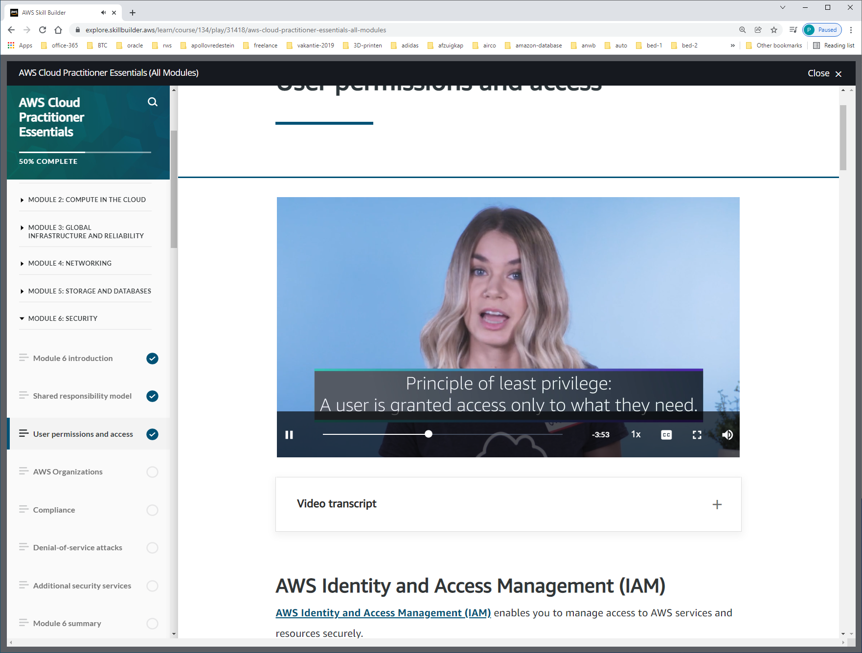

An **IAM policy** is a document that allows or denies permissions to AWS services and resources.    
IAM policies enable you to customize users’ levels of access to resources. For example, you can allow users to access all of the Amazon S3 buckets within your AWS account, or only a specific bucket.

Een JSON-policy voor een user:

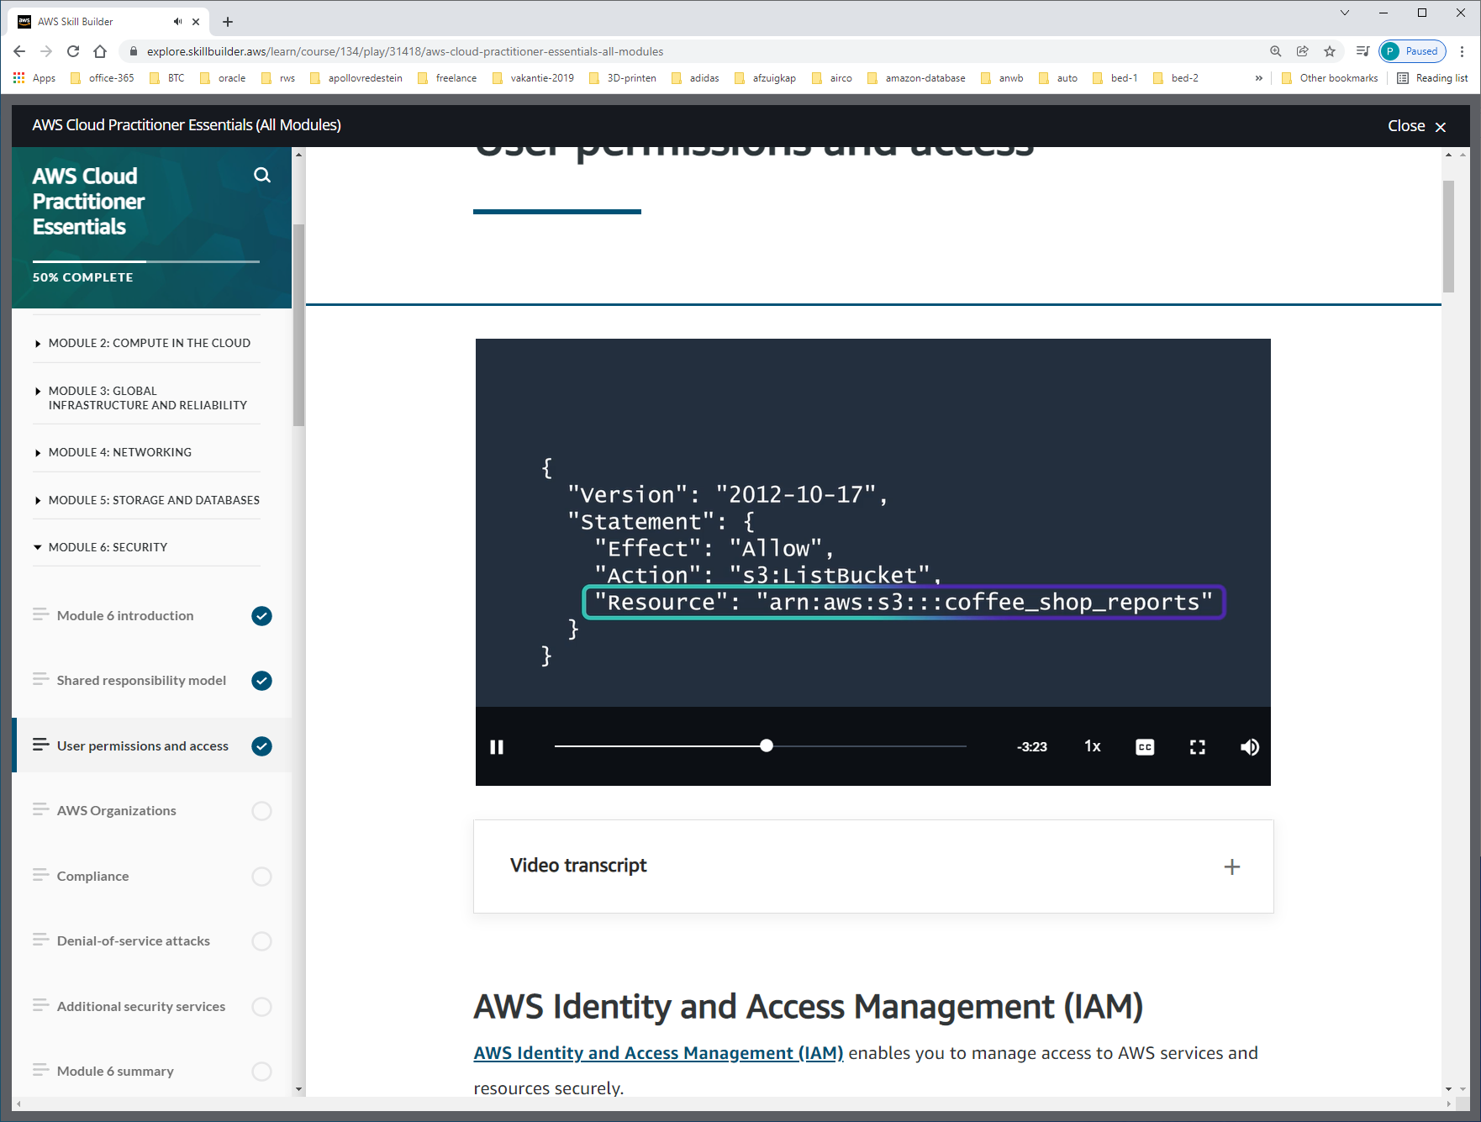

Effect: allow / deny  
Action: any AWS api-call  
Resouce: ARN

Een policy kun je koppelen aan een USER-GROUP.

ROLES

An IAM role is an identity that you can assume to gain temporary access to permissions.

Before an IAM user, application, or service can assume an IAM role, they must be granted permissions to switch to the role. When someone assumes an IAM role, they abandon all previous permissions that they had under a previous role and assume the permissions of the new role.

IAM roles are ideal for situations in which access to services or resources needs to be granted temporarily, instead of long-term.

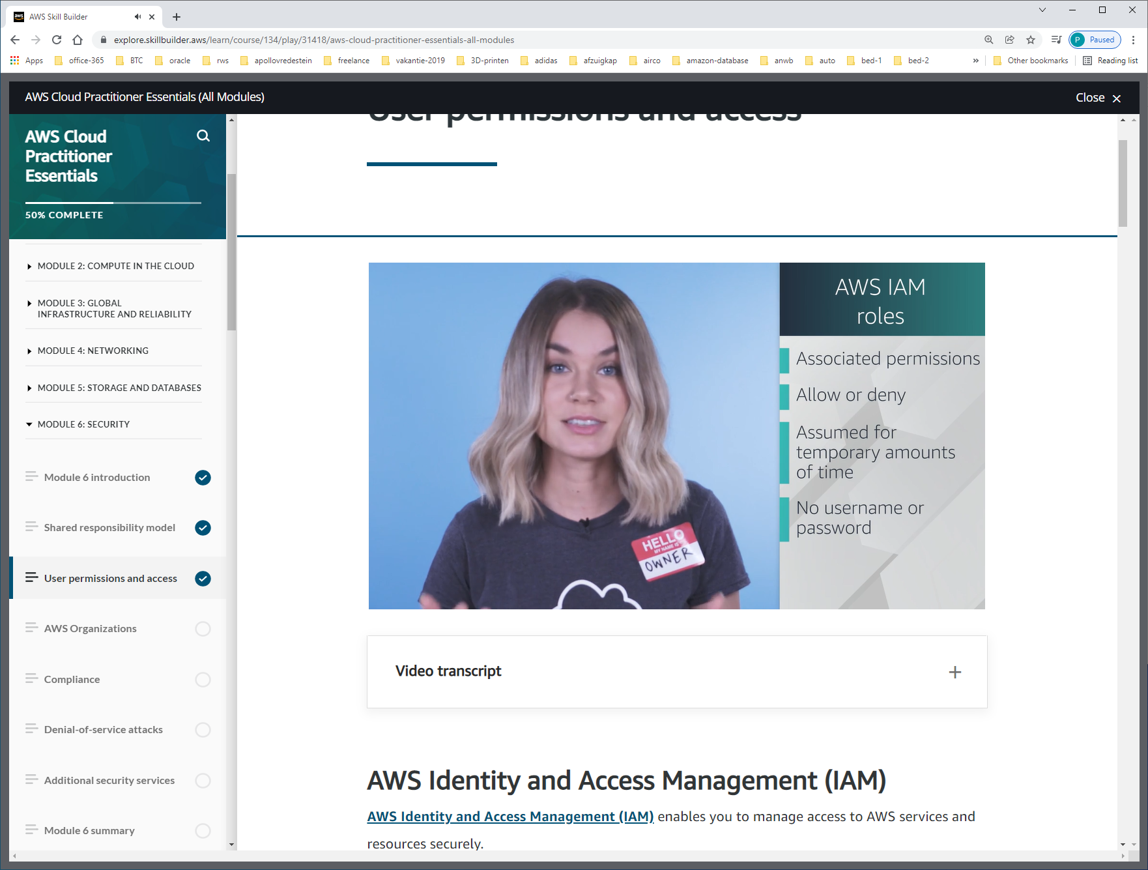

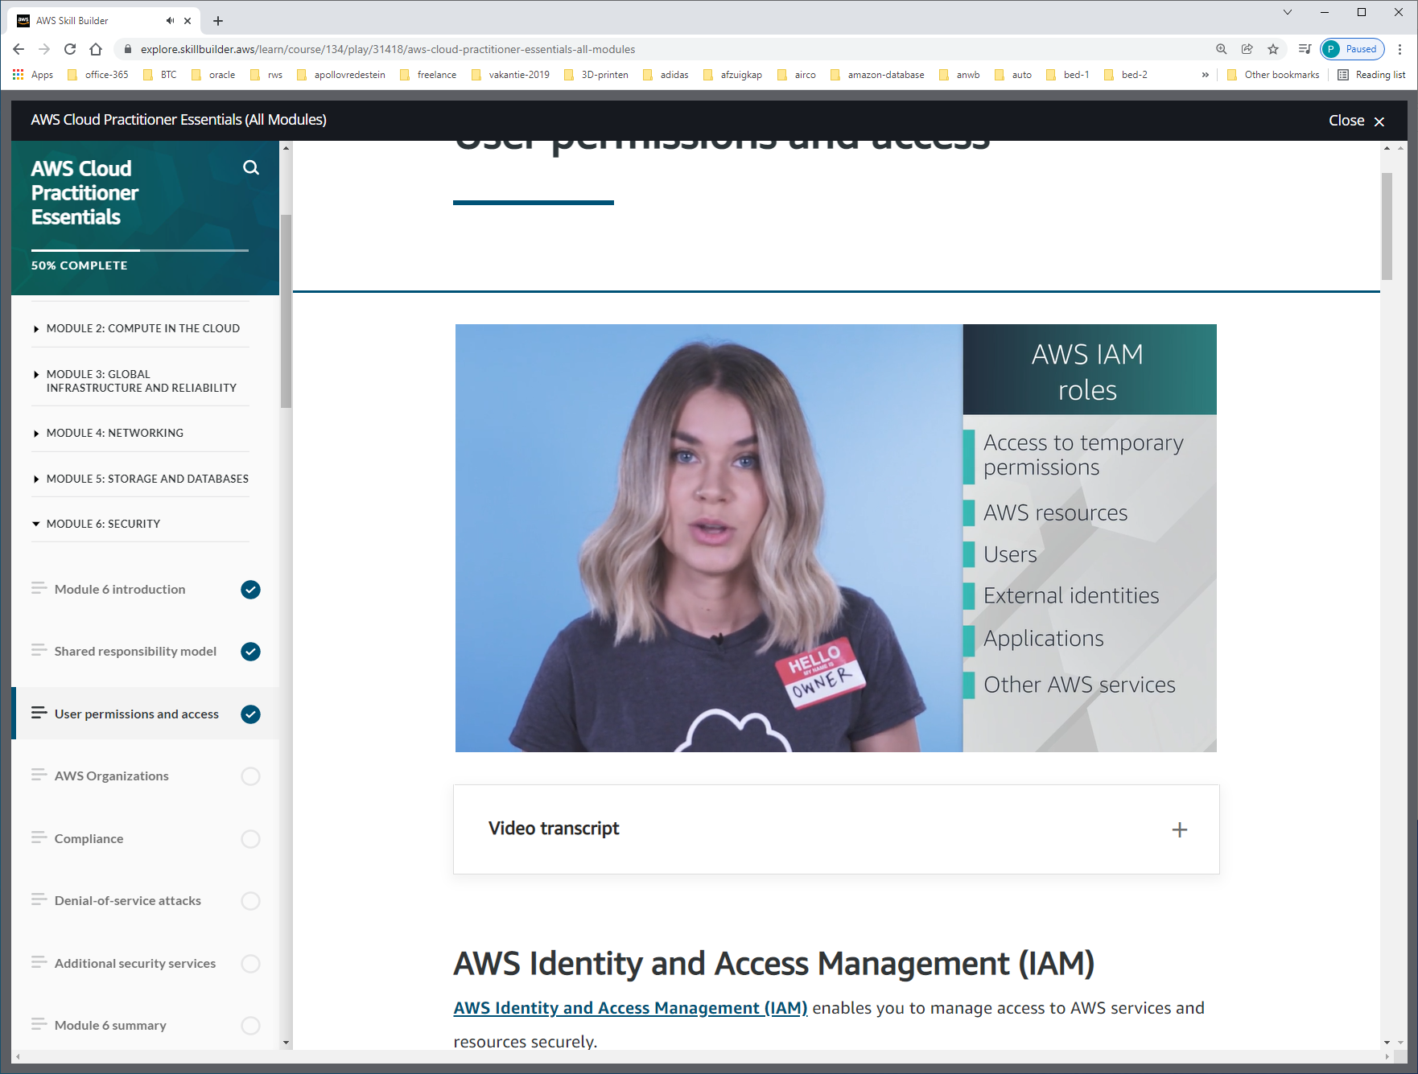

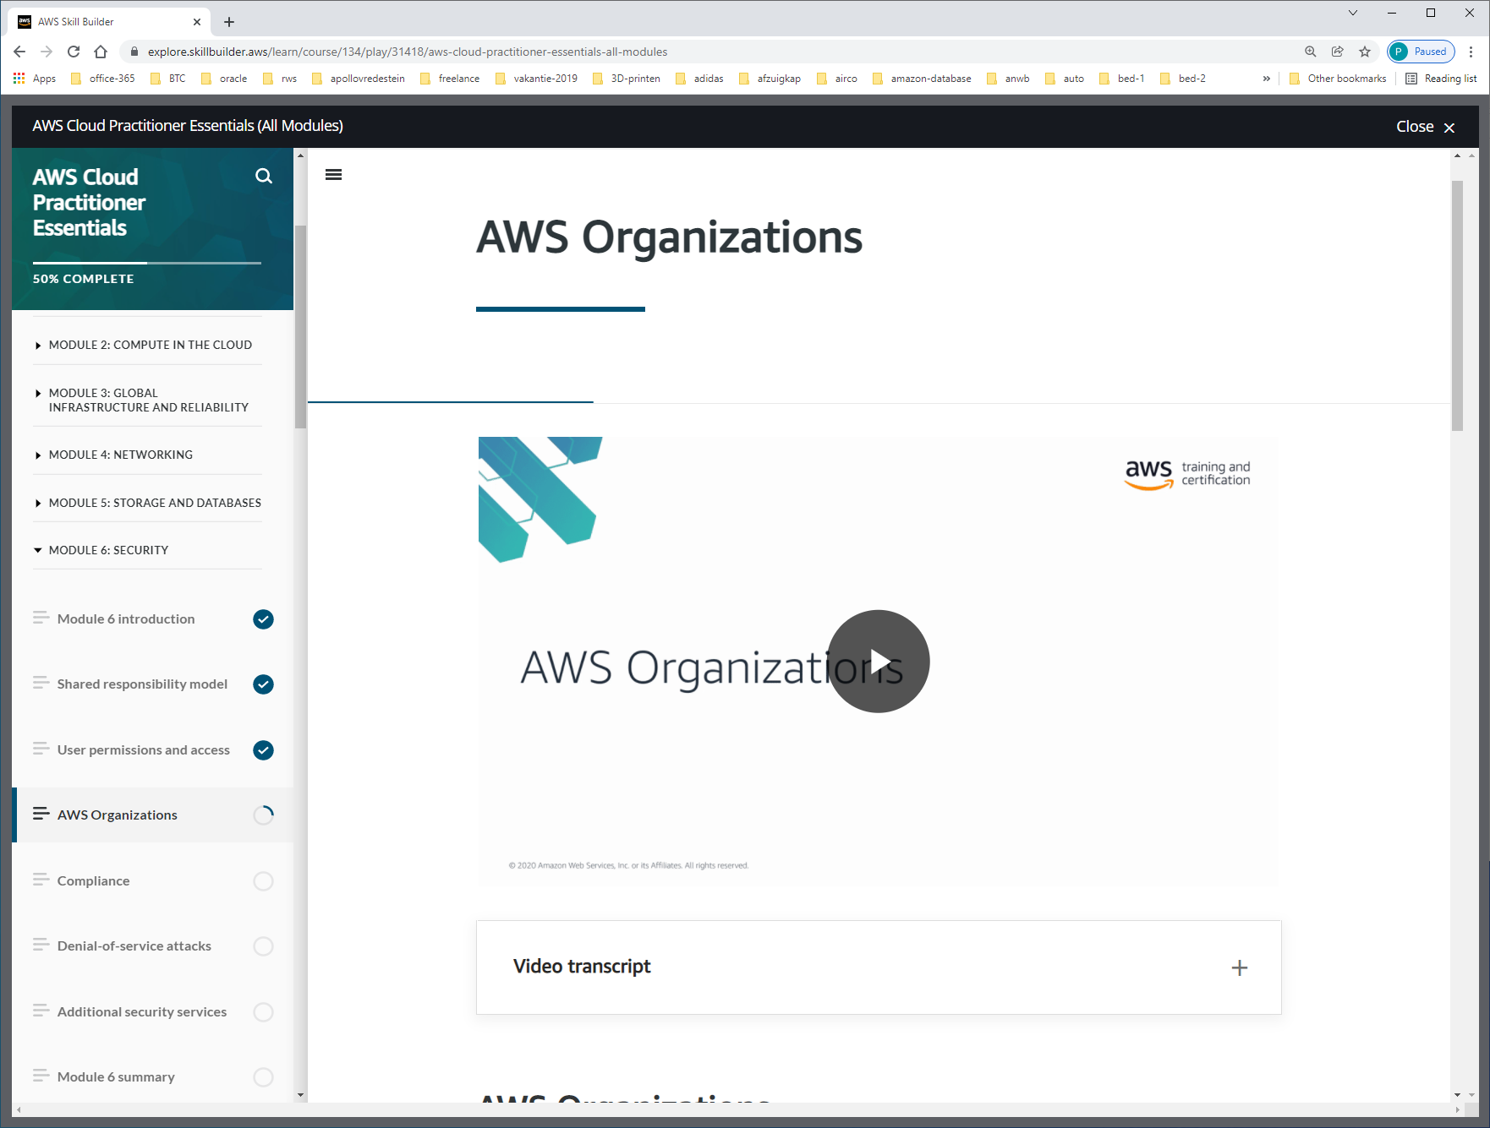

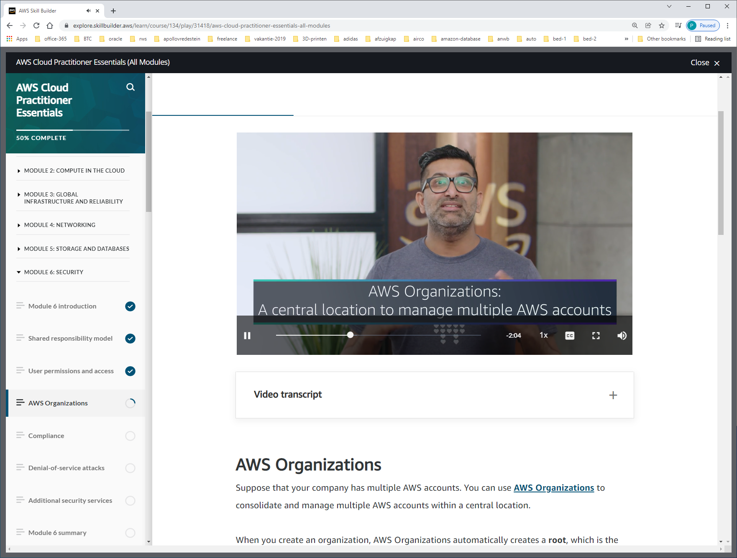

Suppose that your company has multiple AWS accounts. You can use [**AWS Organizations**](https://aws.amazon.com/organizations)to consolidate and manage multiple AWS accounts within a central location.

When you create an organization, AWS Organizations automatically creates a **root**, which is the parent container for all the accounts in your organization.

Manage, billing, access, compliance, security

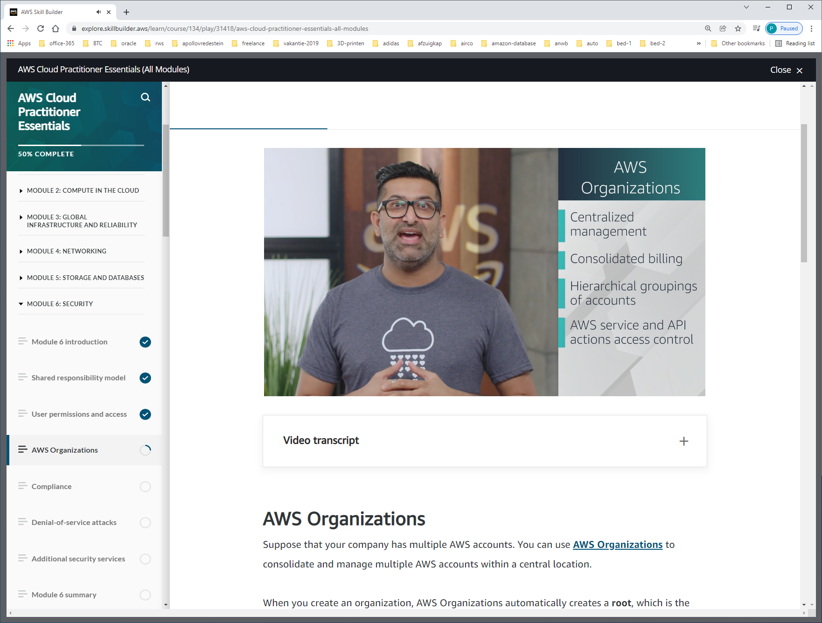

SCP = SERVICE CONTROL POLICIES, welke api's user/roles can access.

In AWS Organizations, you can centrally control permissions for the accounts in your organization by using [**service control policies (SCPs)**](https://docs.aws.amazon.com/organizations/latest/userguide/orgs_manage_policies_scps.html). SCPs enable you to place restrictions on the AWS services, resources, and individual API actions that users and roles in each account can access.

In AWS Organizations, you can group accounts into organizational units (OUs) to make it easier to manage accounts with similar business or security requirements. When you apply a policy to an OU, all the accounts in the OU automatically inherit the permissions specified in the policy.

By organizing separate accounts into OUs, you can more easily isolate workloads or applications that have specific security requirements. For instance, if your company has accounts that can access only the AWS services that meet certain regulatory requirements, you can put these accounts into one OU. Then, you can attach a policy to the OU that blocks access to all other AWS services that do not meet the regulatory requirements.

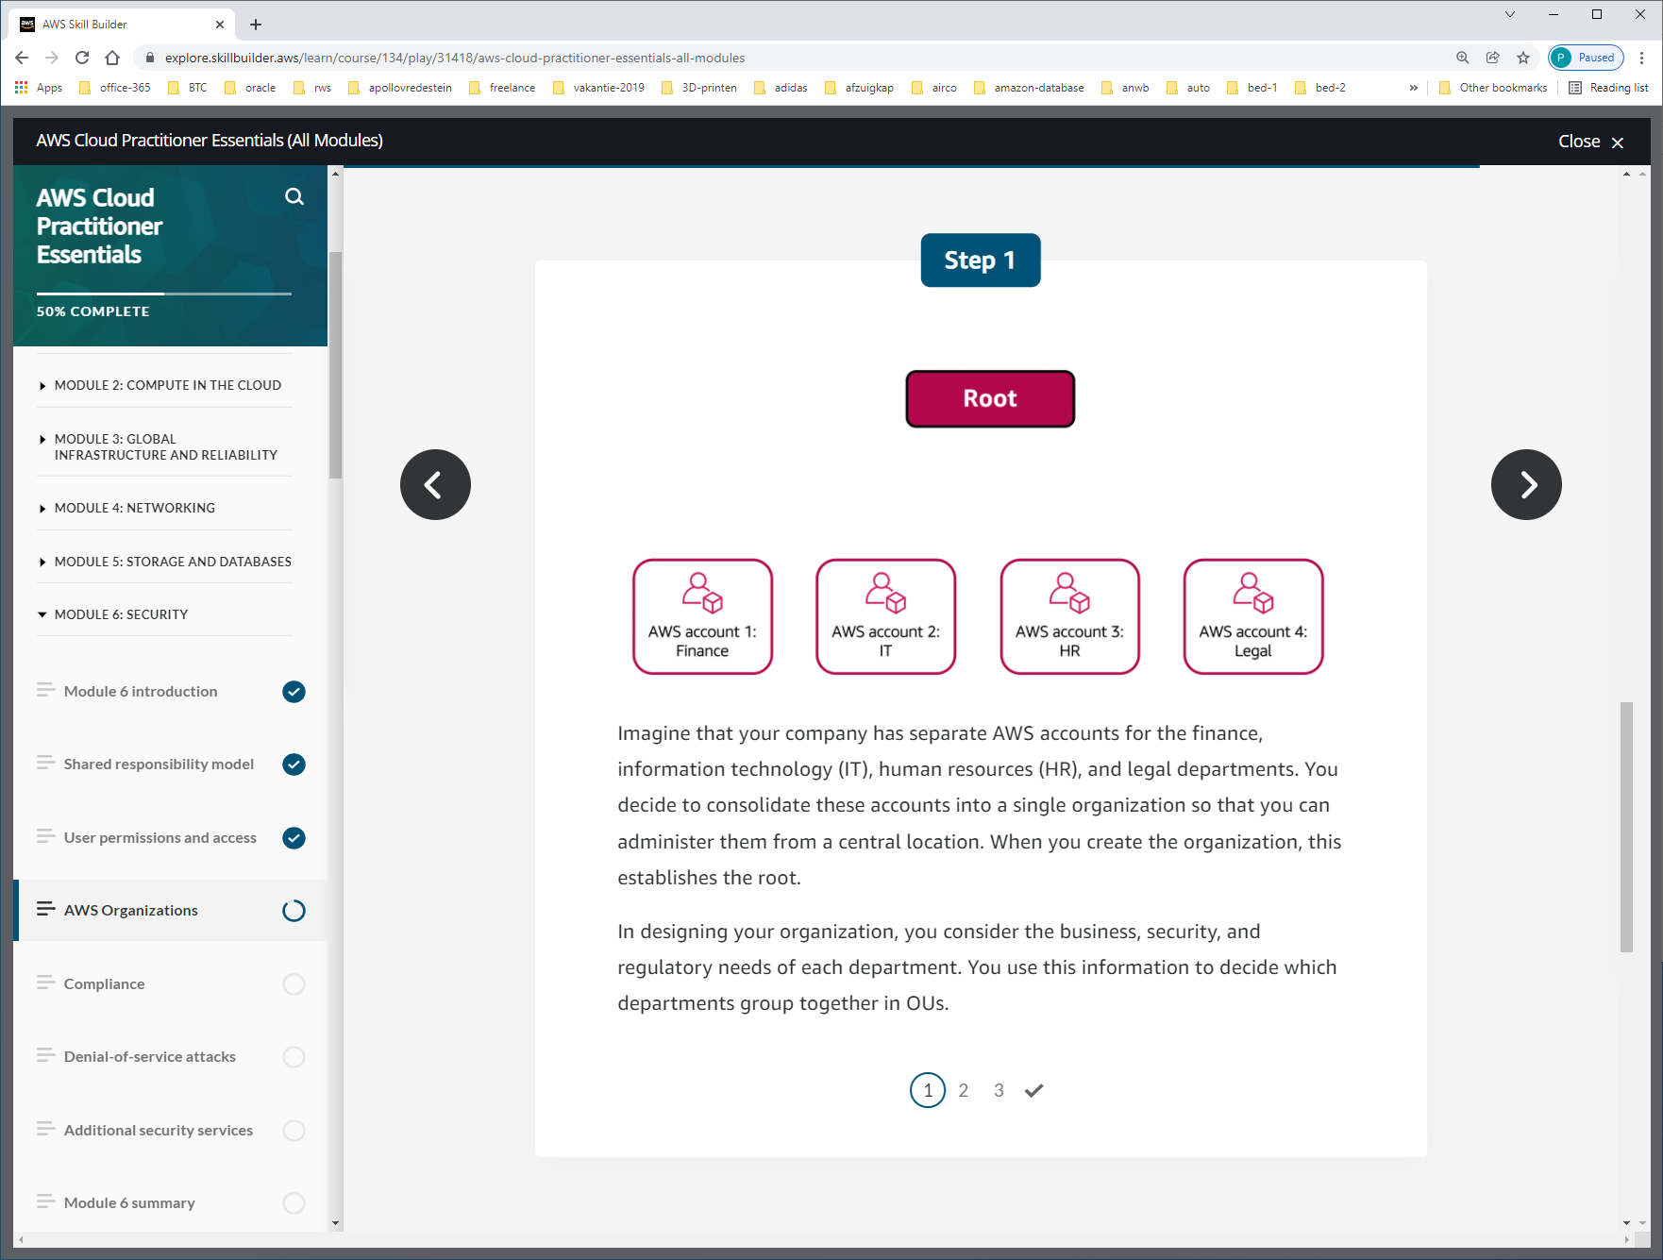

When you create the organization, this establishes the root.

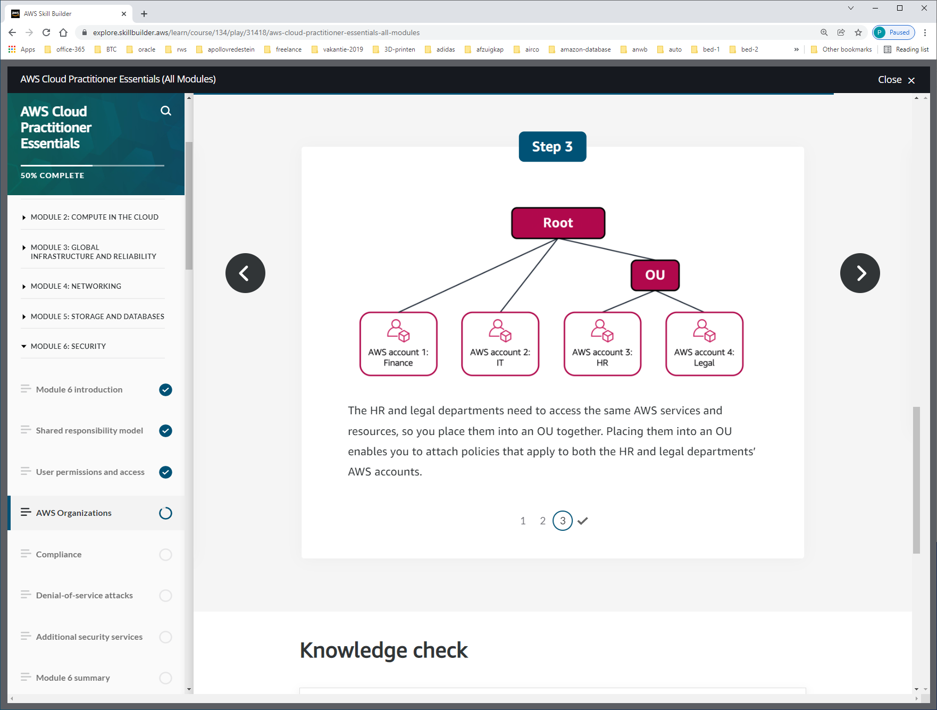

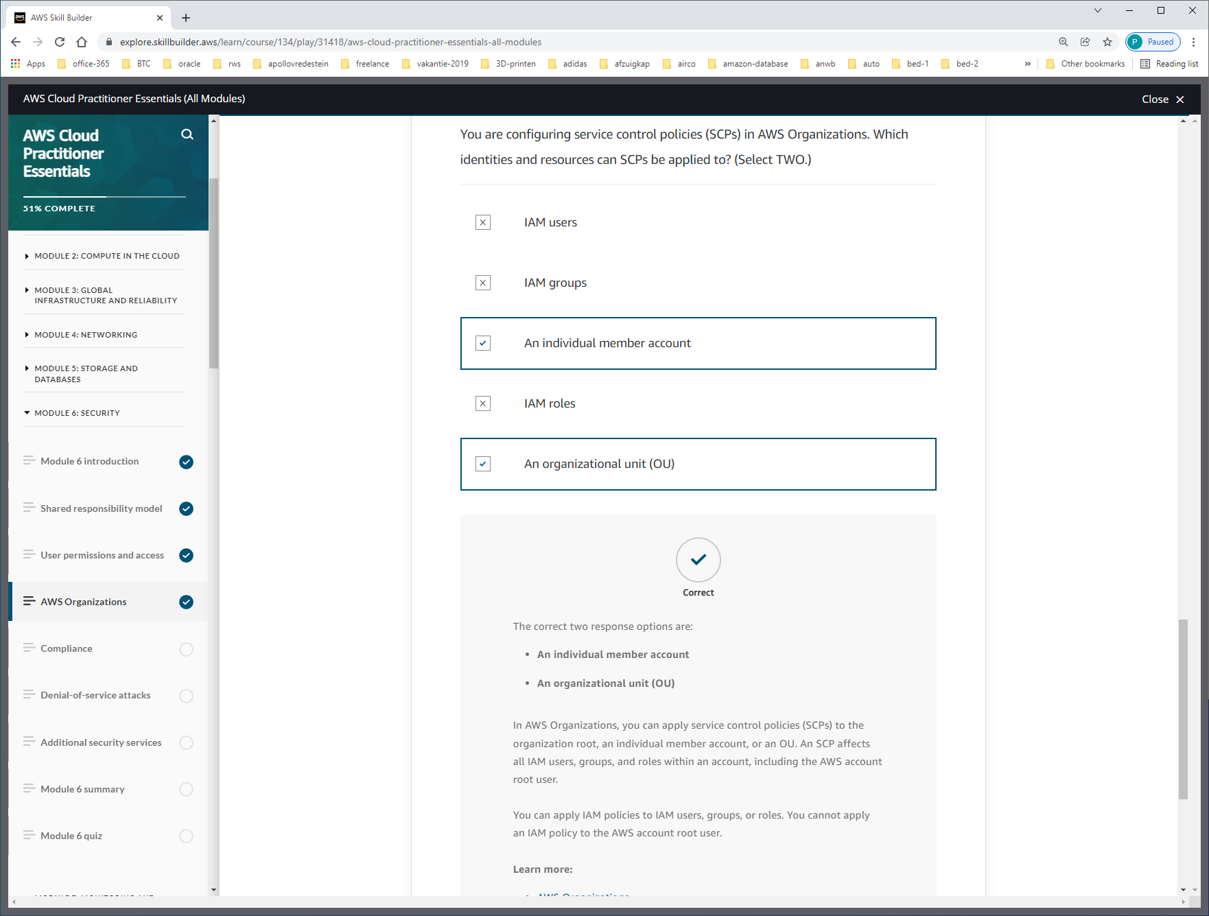

In AWS Organizations, you can apply **service control policies (SCPs)** to the   
-organization root,   
-an individual member account,   
-or an OU.   
An SCP affects all IAM users, groups, and roles within an account, including the AWS account root user.

You can apply **IAM policies** to   
-IAM users,   
-groups,   
-or roles.   
You cannot apply an IAM policy to the AWS account root user.

DUS verschil IAM-POLICY + SCP

An **IAM policy** is a document that allows or denies permissions to AWS services and resources.    
IAM policies enable you to customize users’ levels of access to resources

Service control policies (SCPs) are a type of organization policy that you can use to manage permissions in your organization. SCPs offer central control over the maximum available permissions for all accounts in your organization. SCPs help you to ensure your accounts stay within your organization’s access control guidelines. SCPs are available only in an organization that has [all features enabled](https://docs.aws.amazon.com/organizations/latest/userguide/orgs_manage_org_support-all-features.html). SCPs aren't available if your organization has enabled only the consolidated billing features. For instructions on enabling SCPs, see [Enabling and disabling policy types](https://docs.aws.amazon.com/organizations/latest/userguide/orgs_manage_policies_enable-disable.html).

SCPs alone are not sufficient to granting permissions to the accounts in your organization. No permissions are granted by an SCP. An SCP defines a guardrail, or sets limits, on the actions that the account's administrator can delegate to the IAM users and roles in the affected accounts. The administrator must still attach [identity-based or resource-based policies](https://docs.aws.amazon.com/IAM/latest/UserGuide/access_policies_identity-vs-resource.html) to IAM users or roles, or to the resources in your accounts to actually grant permissions. The [effective permissions](https://docs.aws.amazon.com/organizations/latest/userguide/orgs_manage_policies_scps.html#scp-effects-on-permissions) are the logical intersection between what is allowed by the SCP and what is allowed by the IAM and resource-based policies.

Important

**SCPs don't affect users or roles in the management account. They affect only the member accounts in your organization.**

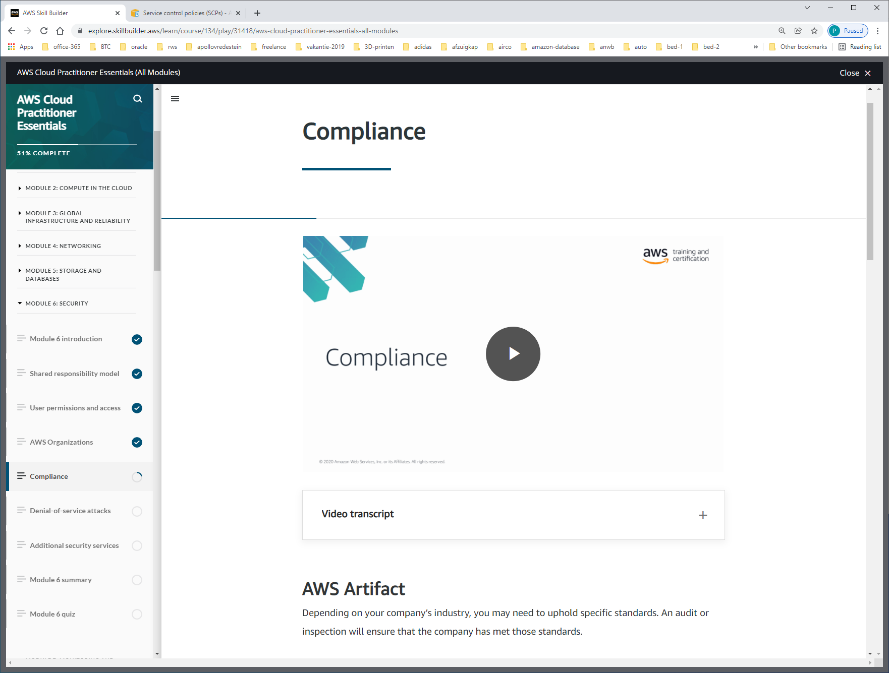

[**AWS Artifact**](https://aws.amazon.com/artifact) is a service that provides on-demand access to AWS **security and compliance** reports and select online agreements. AWS Artifact consists of two main sections: AWS Artifact Agreements and AWS Artifact Reports.

**AWS Artifact Agreements**

Suppose that your company needs to sign an agreement with AWS regarding your use of certain types of information throughout AWS services. You can do this through **AWS Artifact Agreements**.

In AWS Artifact Agreements, you can review, accept, and manage agreements for an individual account and for all your accounts in AWS Organizations. Different types of agreements are offered to address the needs of customers who are subject to specific regulations, such as the Health Insurance Portability and Accountability Act (HIPAA).

**AWS Artifact Reports**

Next, suppose that a member of your company’s development team is building an application and needs more information about their responsibility for complying with certain regulatory standards. You can advise them to access this information in **AWS Artifact Reports**.

AWS Artifact Reports provide compliance reports from third-party auditors. These auditors have tested and verified that AWS is compliant with a variety of global, regional, and industry-specific security standards and regulations. AWS Artifact Reports remains up to date with the latest reports released. You can provide the AWS audit artifacts to your auditors or regulators as evidence of AWS security controls.

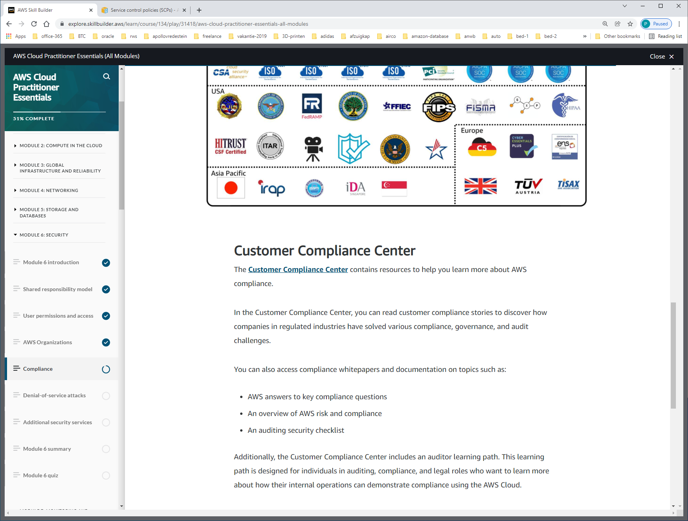

The [**Customer Compliance Center**](https://aws.amazon.com/compliance/customer-center/) contains resources to help you learn more about AWS compliance.

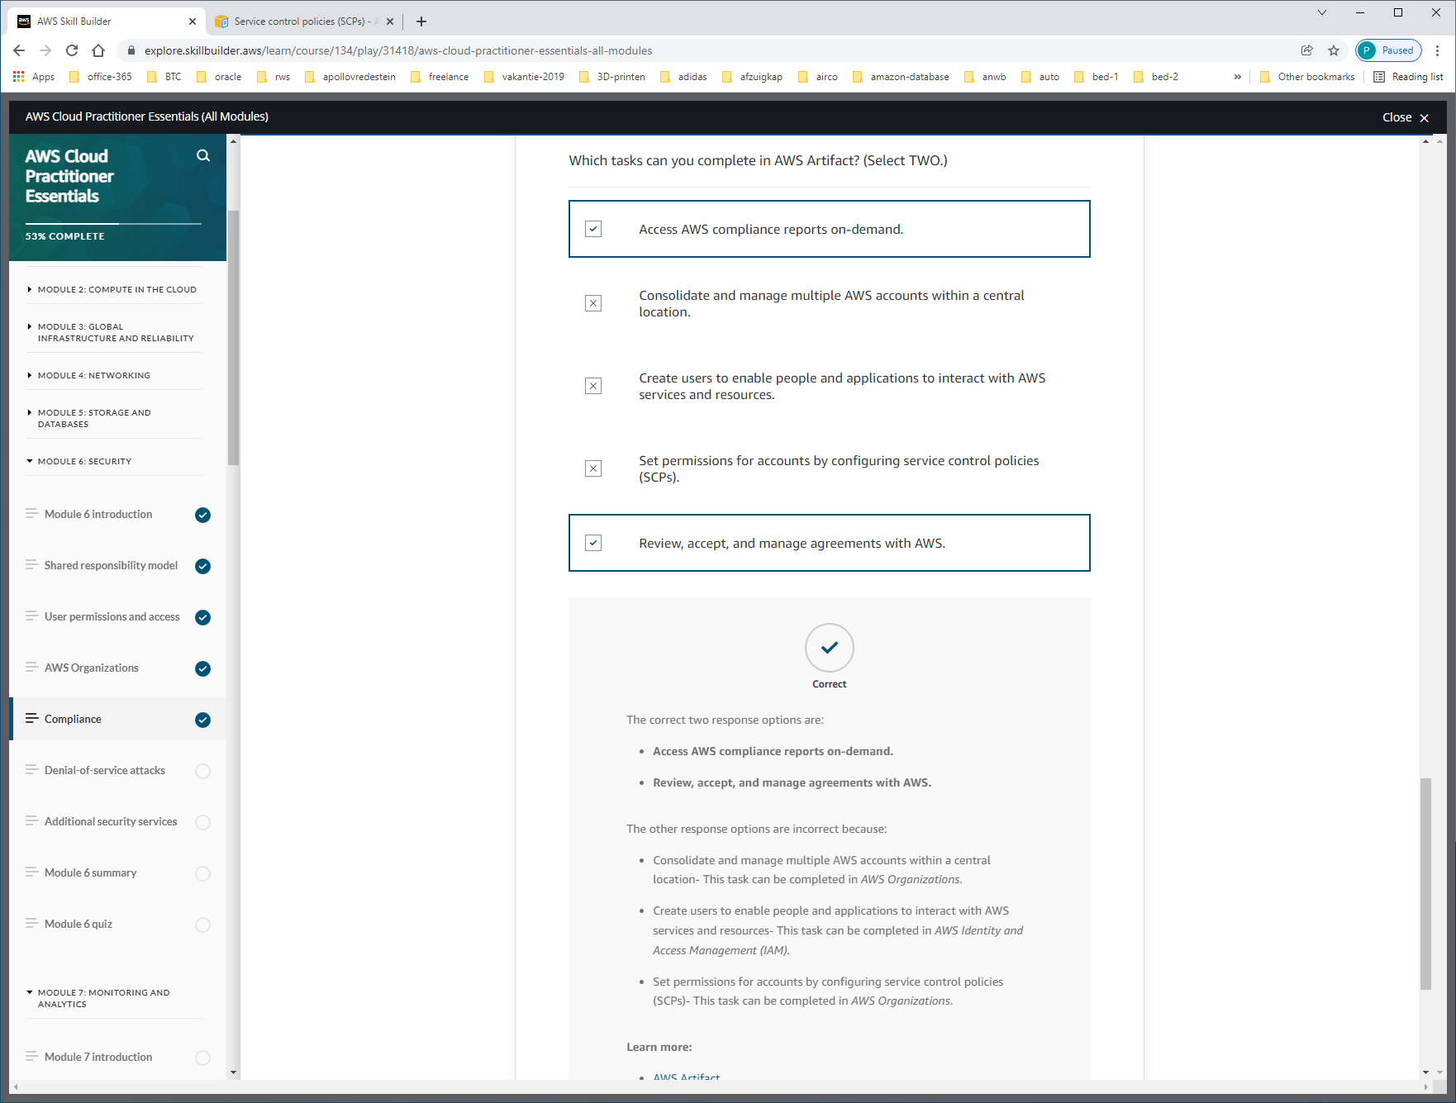

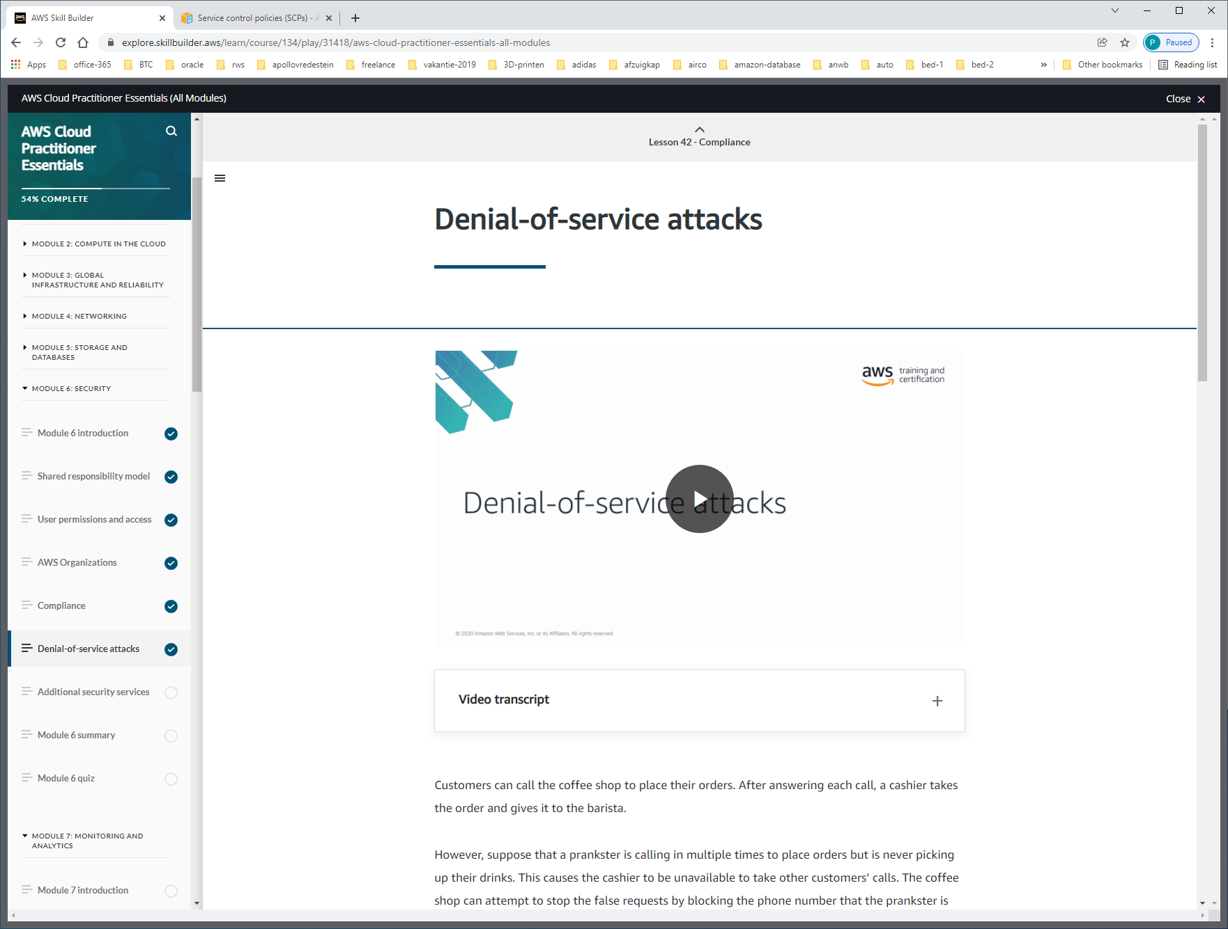

DDOS = Distributed Denial-of-Service

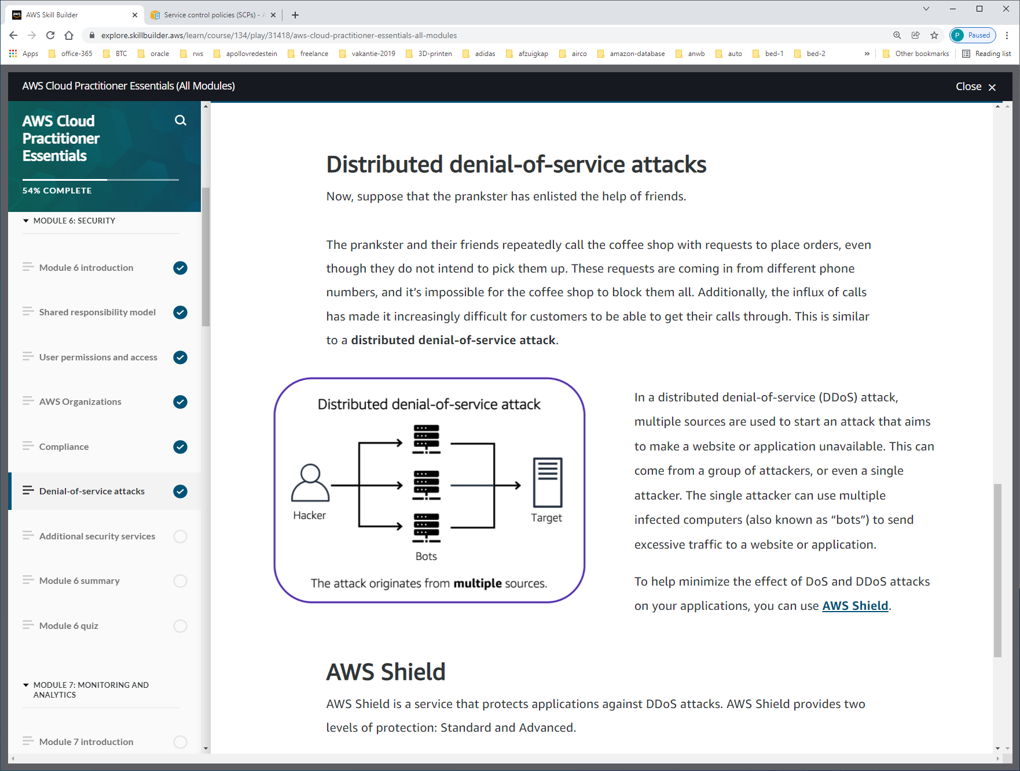

A **denial-of-service (DoS) attack** is a deliberate attempt to make a website or application unavailable to users.

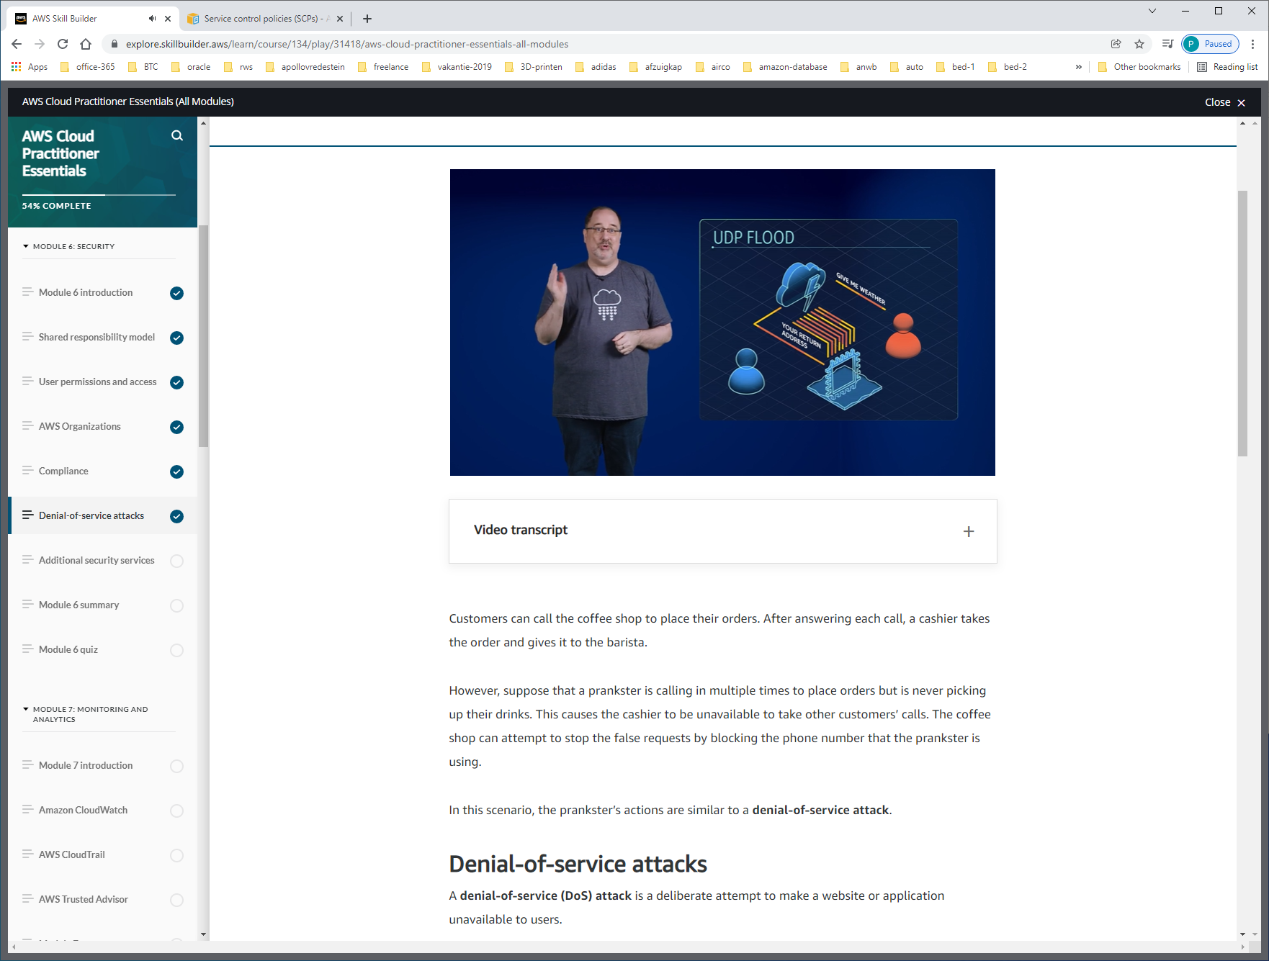

Met fake-return-adres kunnen ze messages naar iemand anders sturen.

OPLOSSING: SECURITY-GROUPS.

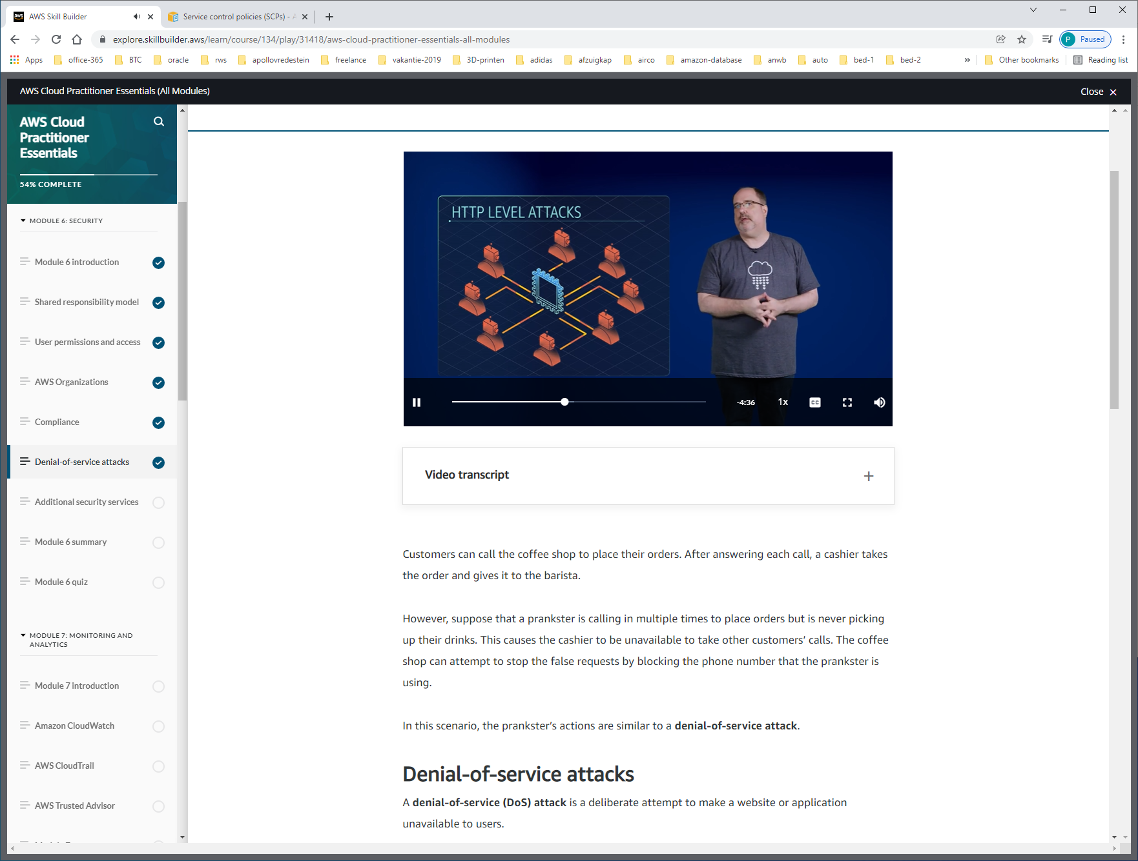

Overbelasting van aantallen requests

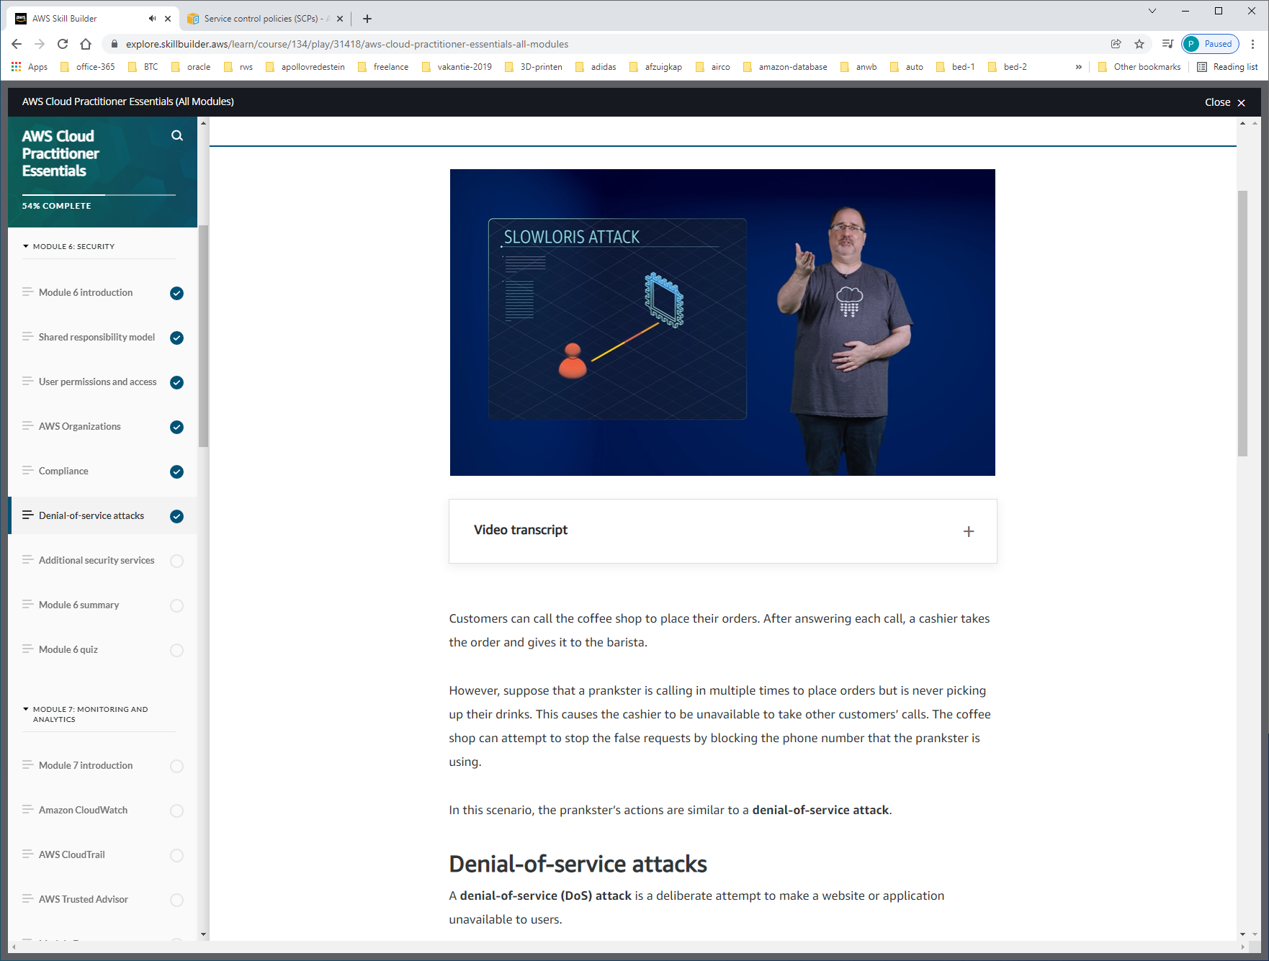

Simulatie van erg trage verbinding.

Oplossing: ELB. Deze handelt verzoek af totdat verzoek volledig binnen is, voordat hij hem doorstuurt naar application-server. ELB werkt binnen region.

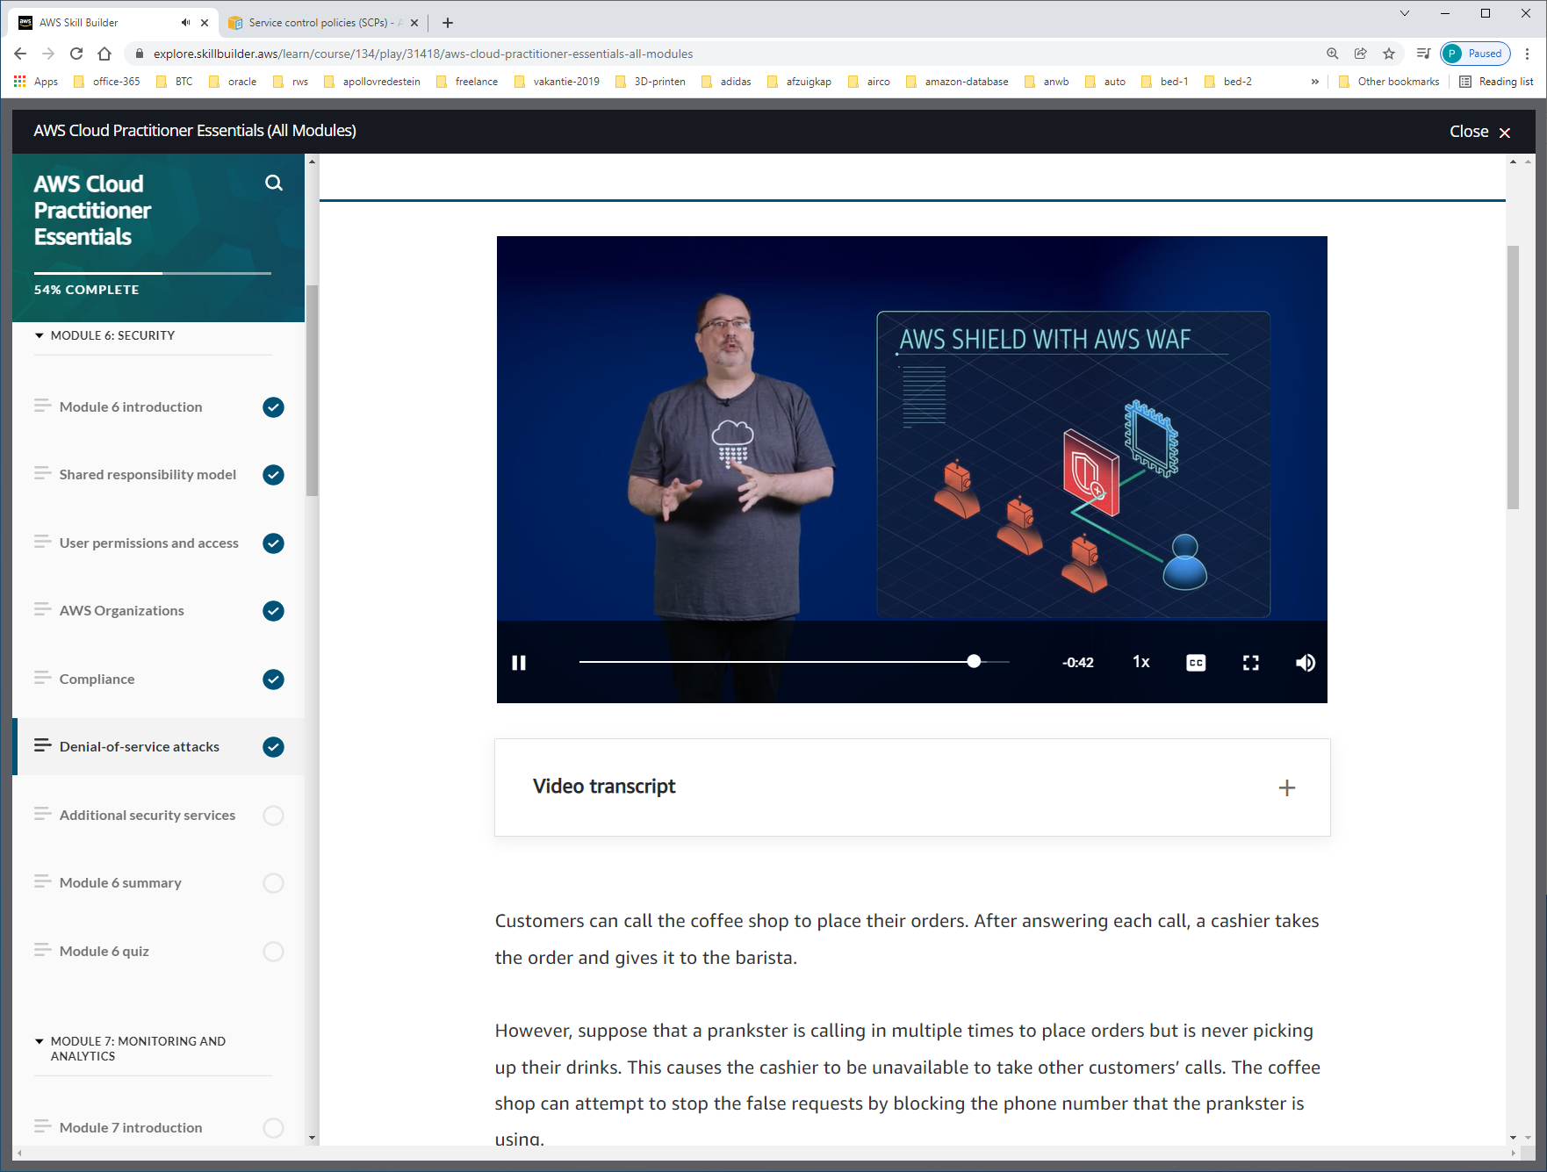

AWS Shield is a service that protects applications against DDoS attacks. AWS Shield provides two levels of protection: Standard and Advanced.

**AWS Shield Standard**

**AWS Shield Standard** automatically protects all AWS customers at no cost. It protects your AWS resources from the most common, frequently occurring types of DDoS attacks.

As network traffic comes into your applications, AWS Shield Standard uses a variety of analysis techniques to detect malicious traffic in real time and automatically mitigates it.

**AWS Shield Advanced**

**AWS Shield Advanced** is a paid service that provides detailed attack diagnostics and the ability to detect and mitigate sophisticated DDoS attacks.

It also integrates with other services such as Amazon CloudFront, Amazon Route 53, and Elastic Load Balancing. Additionally, you can integrate AWS Shield with AWS WAF by writing custom rules to mitigate complex DDoS attacks.

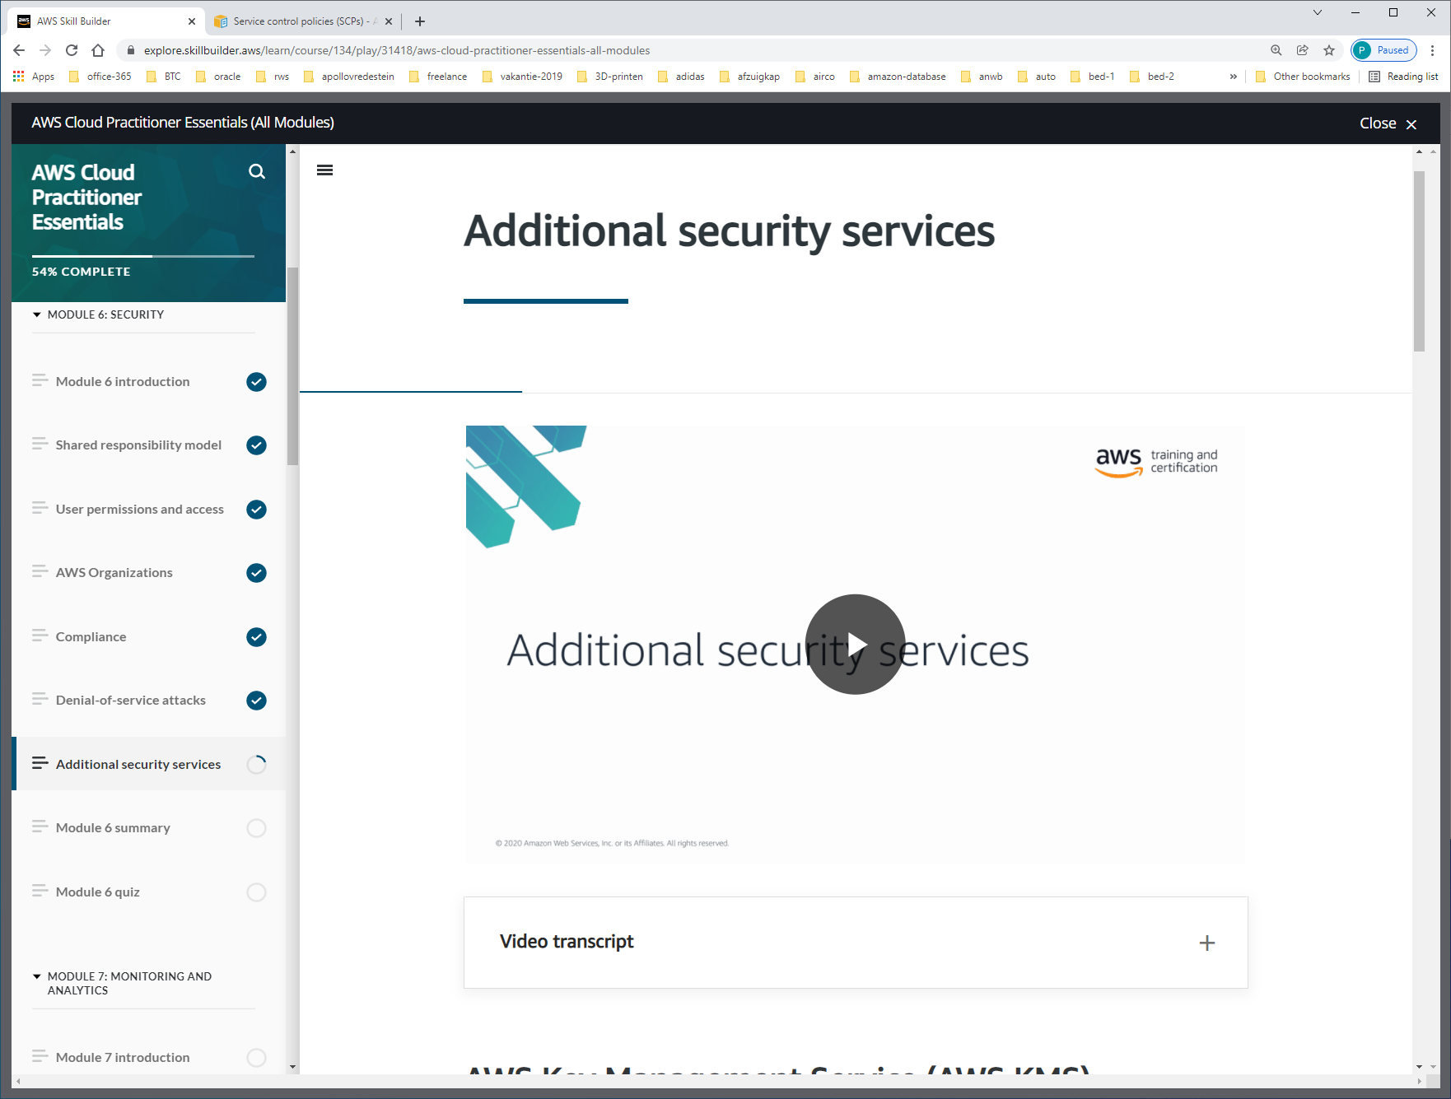

[**AWS Key Management Service (AWS KMS)**](https://aws.amazon.com/kms) enables you to perform encryption operations through the use of **cryptographic keys**.

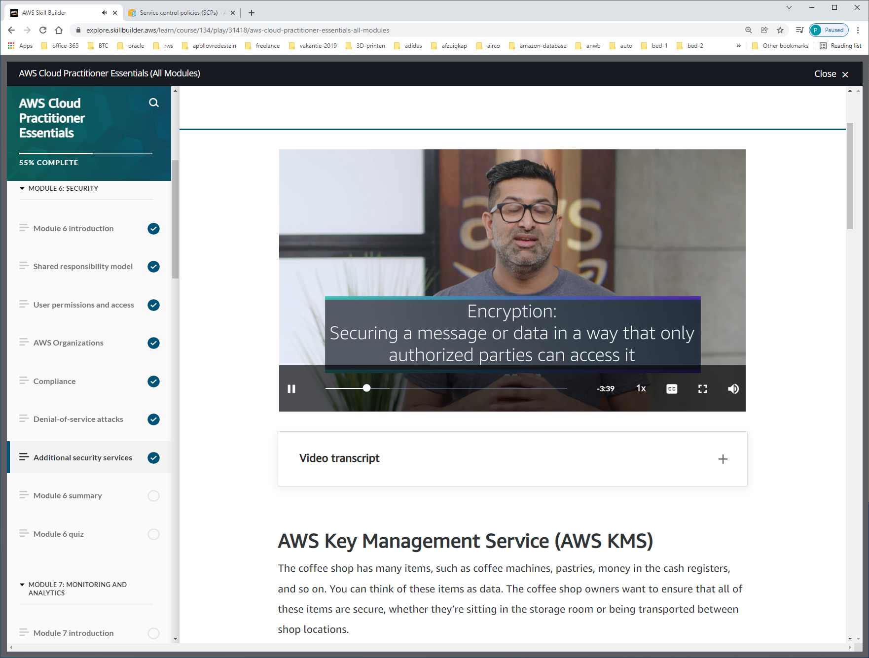

In the same way, you must ensure that your applications’ data is secure while in storage **(encryption at rest)** and while it is transmitted, known as **encryption in transit**.

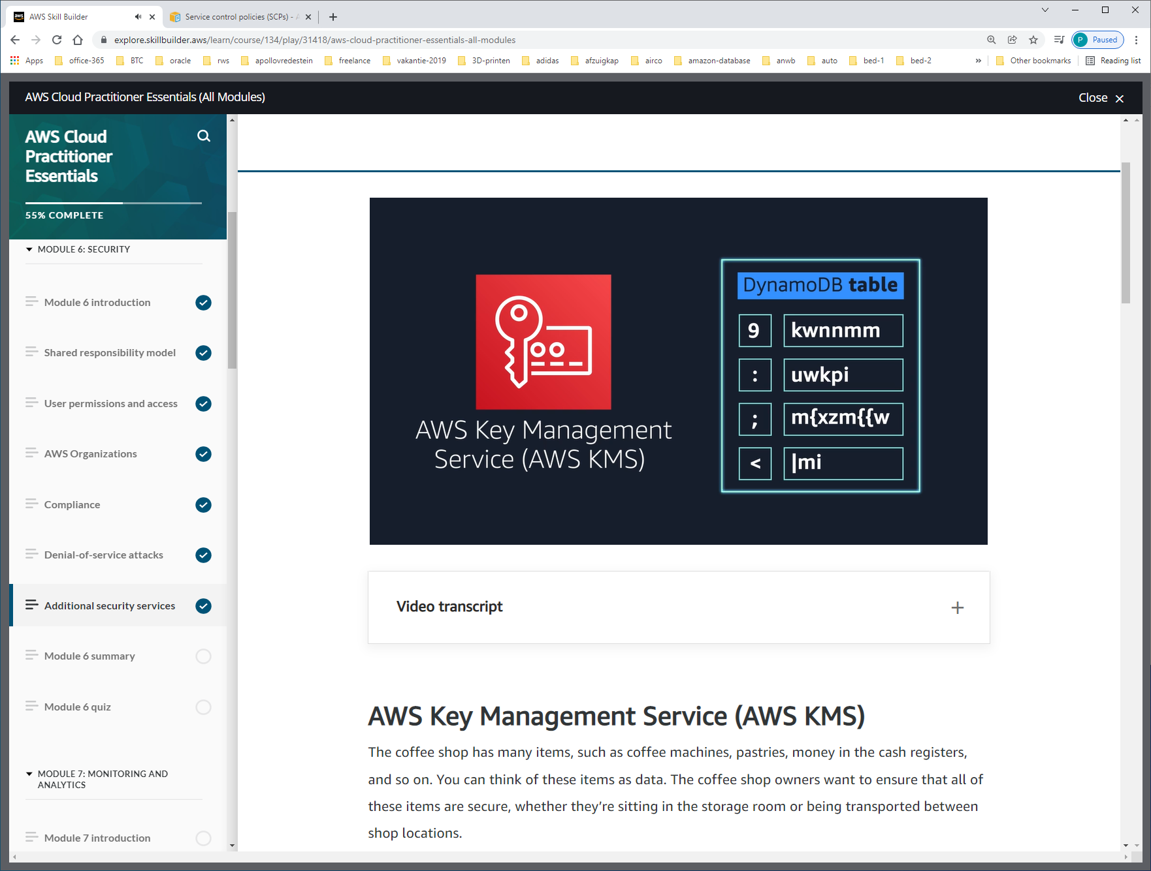

Server-side encryption in REST. Standaard voor dynamo-db.

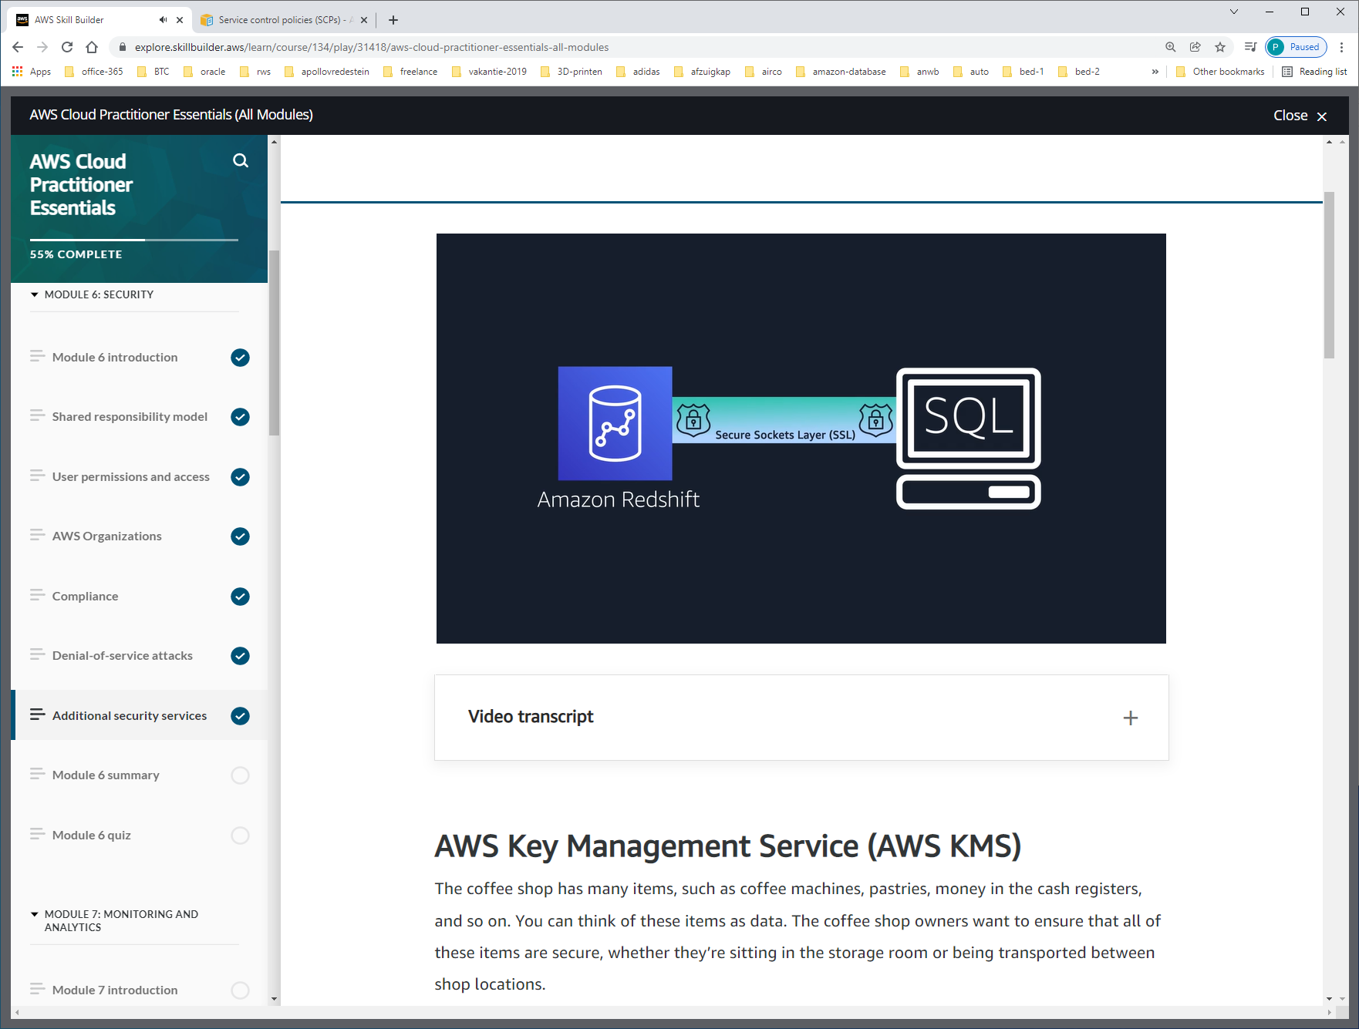

Certificates voor verificatie, encryption in transit.

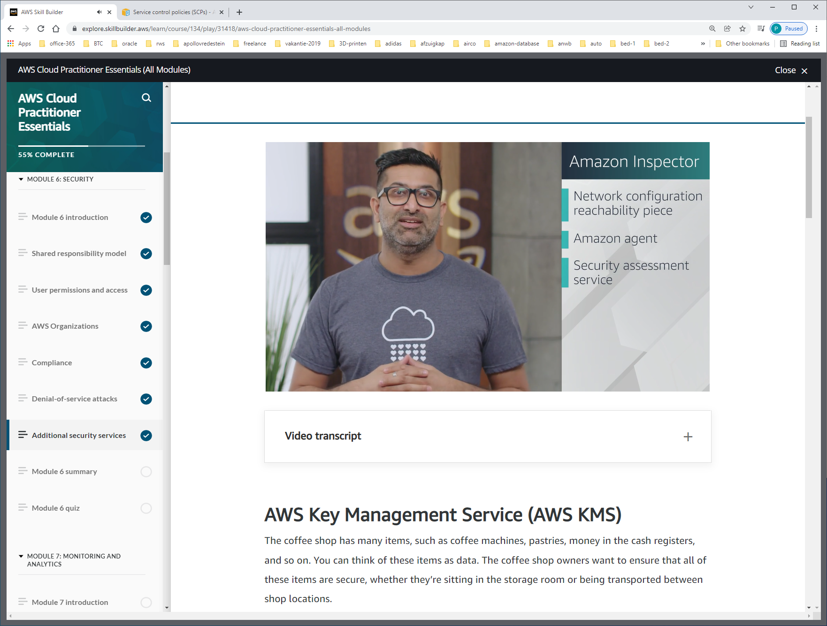

Amazon Inspector helps to improve the security and compliance of applications by running automated security assessments. It checks applications for security vulnerabilities and deviations from security best practices, such as open access to Amazon EC2 instances and installations of vulnerable software versions.

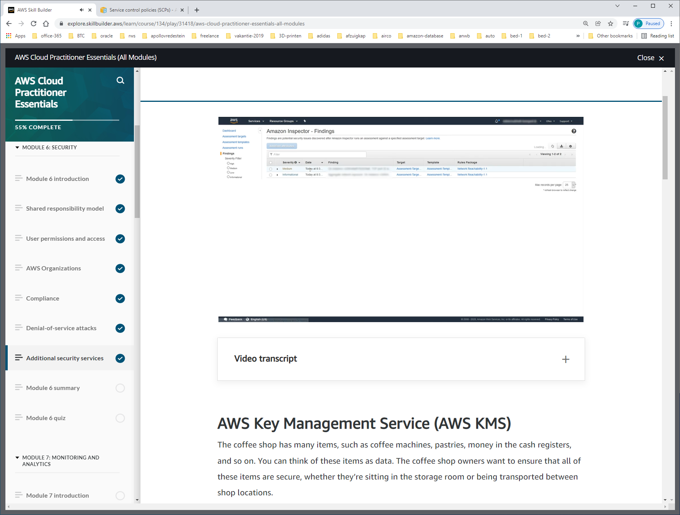

Results van inspector.

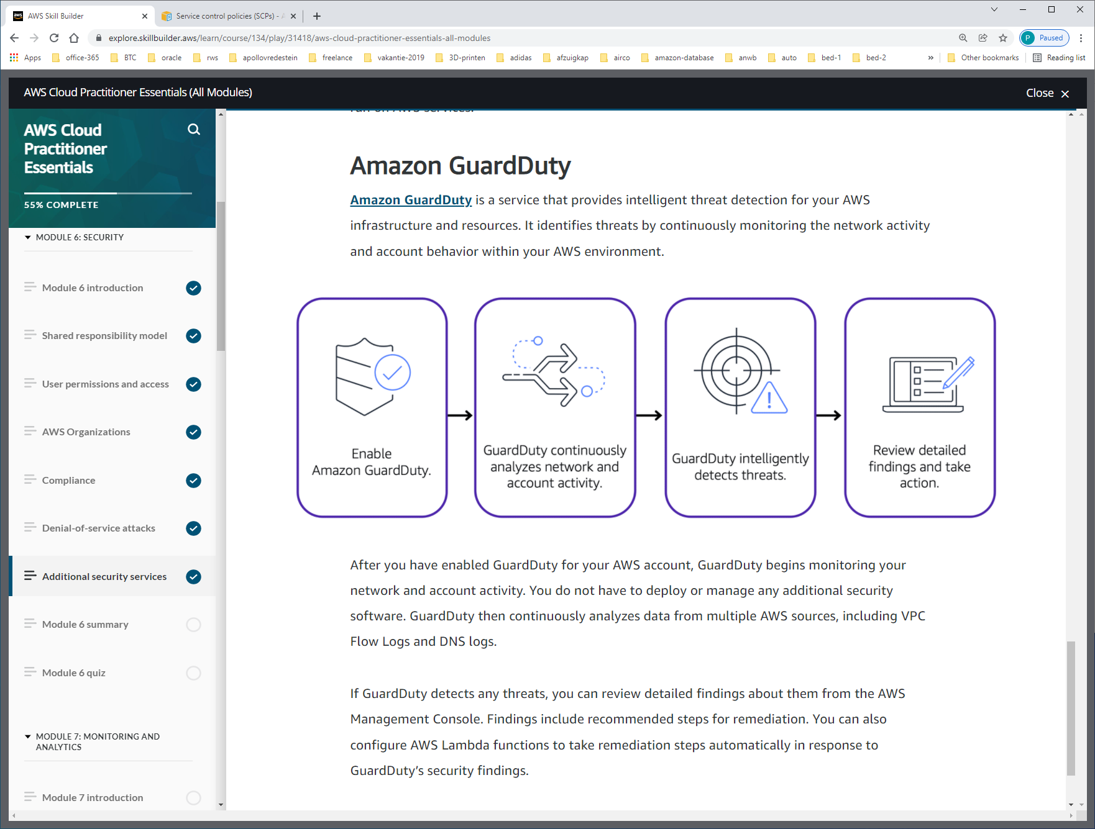

[**Amazon GuardDuty**](https://aws.amazon.com/guardduty) is a service that provides intelligent threat detection for your AWS infrastructure and resources. It **identifies threats by continuously monitoring the network activity and account behavior within your AWS environment**.

After you have enabled **GuardDuty** for your AWS account, GuardDuty begins monitoring your network and account activity. You do not have to deploy or manage any additional security software. GuardDuty then continuously analyzes data from multiple AWS sources, including VPC Flow Logs and DNS logs.

If GuardDuty detects any threats, you can review detailed findings about them from the AWS Management Console. Findings include recommended steps for remediation. You can also configure AWS Lambda functions to take remediation steps automatically in response to GuardDuty’s security findings.

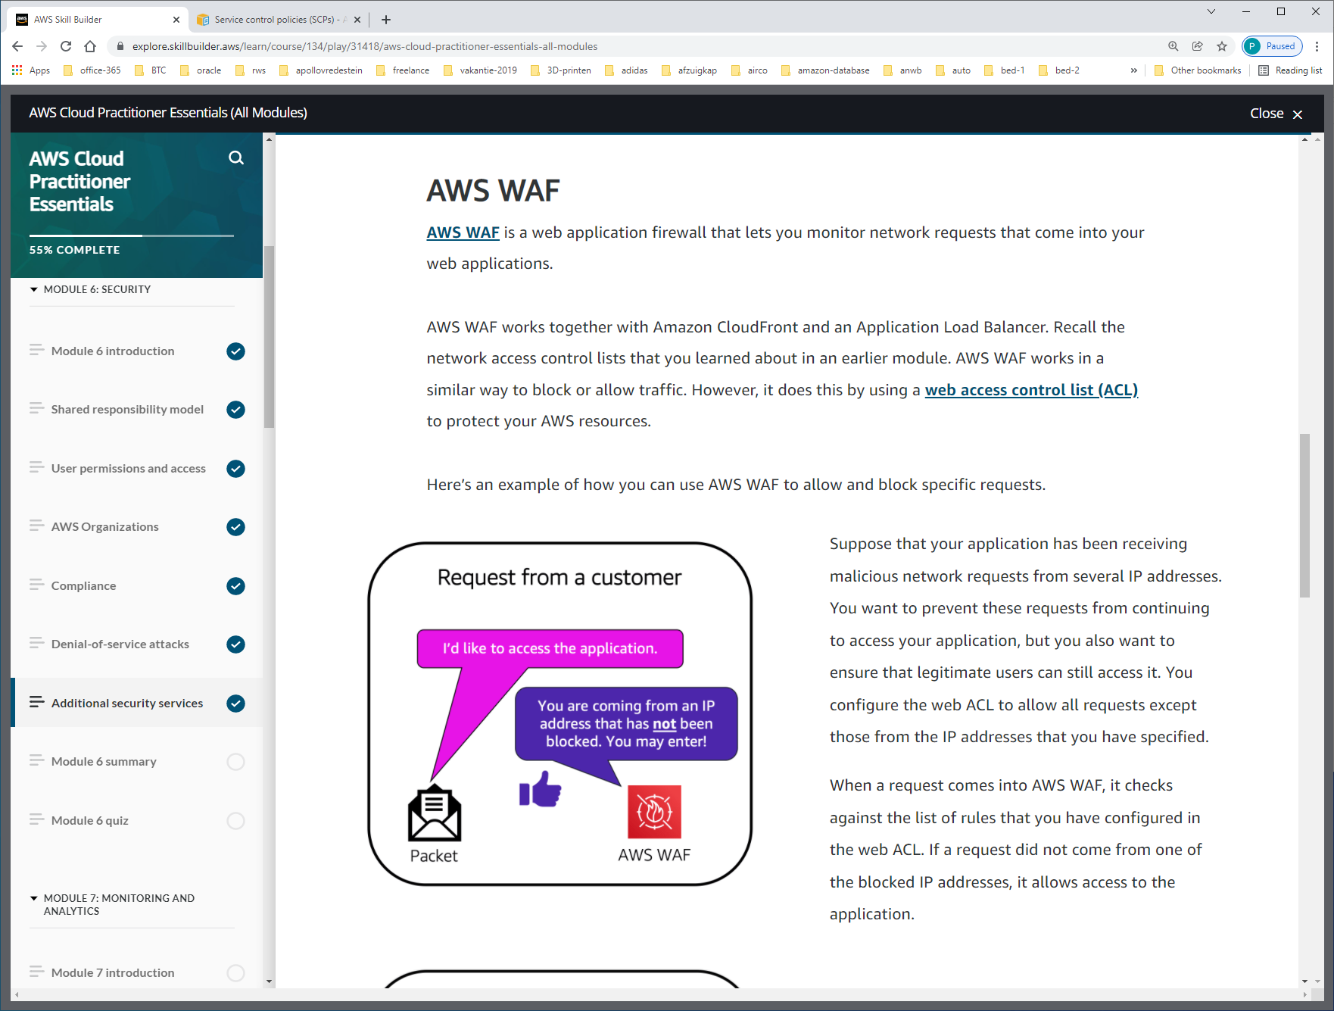

AWS WAF works together with Amazon CloudFront and an Application Load Balancer. Recall the network access control lists that you learned about in an earlier module. AWS WAF works in a similar way to block or allow traffic. However, it does this by using a [**web access control list (ACL)**](https://docs.aws.amazon.com/waf/latest/developerguide/web-acl.html) to protect your AWS resources.

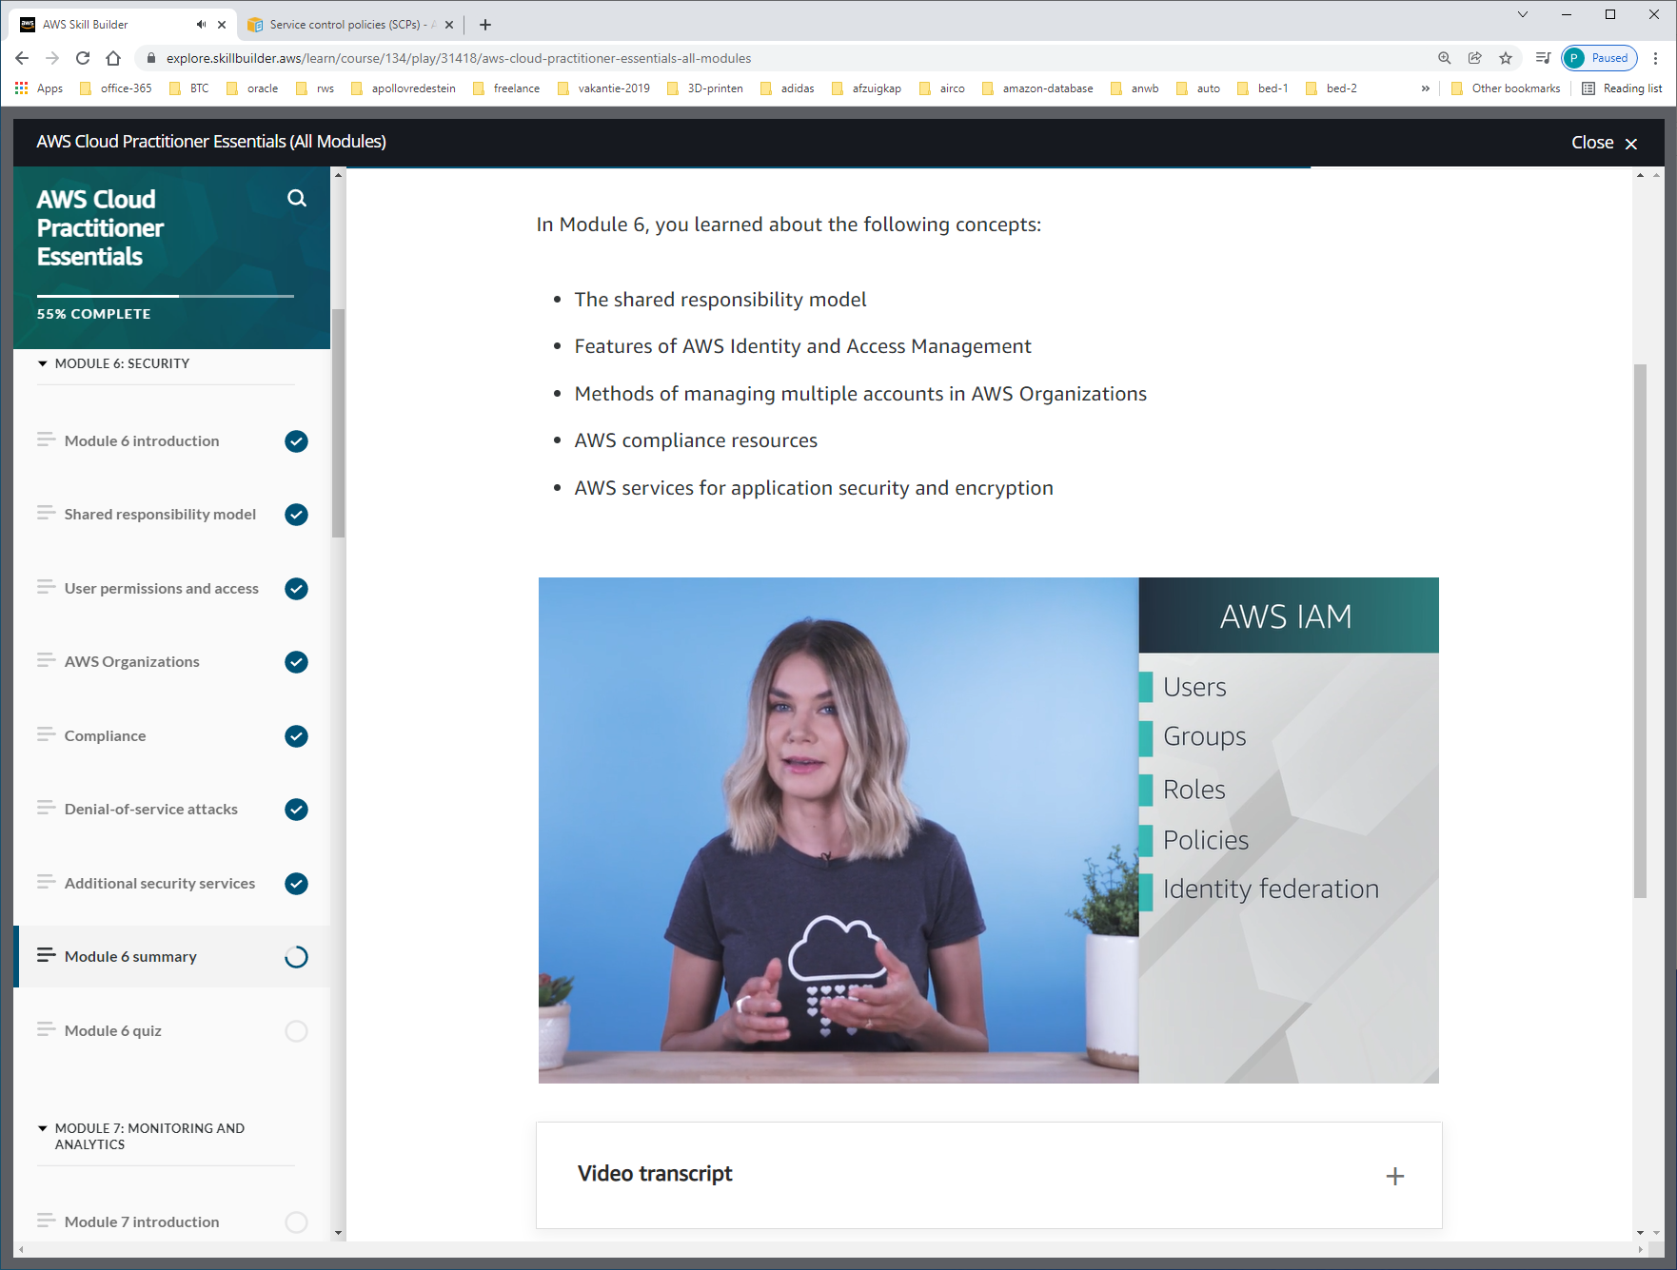

Identity-federation: zorgt ervoor dat bedrijfsaccount gebruikt kan worden in AWS-omgeving !!!

